Panel Reference | PPSSTH-43
DA Number | 20/1069
LGA | Wingecarribee Shire
Proposed Development | Tourist and Visitor Accommodation - Refurbishment of the existing hotel, a four-storey addition to the rear of the hotel to accommodate 46 new rooms, an ancillary function centre and new basement car parking. 13 new eco-tourist cabins, 7 new eco-tourist villas, new swimming pool and leisure centre, Amphitheatre, animal petting area, refurbishment of the workers cottage into an artist studio, a new reception and new internal roads and pedestrian pathways.
Street Address | The Robertson Hotel,1 Fountaindale Road, Robertson, NSW 2577.
Applicant/Owner | AEA GRAND HOTEL PTY LTD
Date of DA lodgement | 20 March 2020
Total number of Submissions  Number of Unique Objections | First Notification (2020) 34  Re-notification (2021) 10
Recommendation | Approval subject to conditions
Regional Development Criteria (Schedule 7 of the SEPP (State and Regional Development) 2011 | Capital Investment Value (CIV) over $30 Million
List of all relevant s4.15(1)(a) matters | List all of the relevant environmental planning instruments: s4.15(1)(a)(i)  - Environment Protection and Biodiversity Conservation Act 1999 (EPBC Act)- CEEC to site and formal referral to Australian Government- Department of Agriculture, Water and the Environment required post consent (where consent is granted);  - Environmental Planning and Assessment Act 1979 – Integrated Development under s91 - Special Fire Purpose under the Rural Fires Act – s100B Authority issued by RFS;  - Environmental Planning and Assessment Act 1979 - Existing Use Rights – for the Hotel which are in continual use and have not been abandoned for a period of 12 months or greater, the site enjoys existing use rights for the hotel and may be expanded under Part 5 of the Environmental Planning and Assessment Regulation 2000;  - Biodiversity Conservation Act 2016 – Has been considered by ecologists as part of this assessment due to presence of EEC across the site;  - State Environmental Planning Policy (Sydney Water Catchment) 2011 – Concurrence sought and received from Water NSW under Part 2, s11;  - State Environmental Planning Policy (Infrastructure) 2007 – Concurrence sought and received from RMS (TfNSW) under Clause 101 as frontage to Classified Road;  - State Environmental Planning Policy No. 55 – Remediation of Land – Not considered to be contaminated, standard conditions recommended;  - State Environmental Planning Policy (BASIX) 2004 -Considered and relevant certificates provided and a Section J report under the BCA;  - State Environmental Planning Policy No. 65 – Design Quality of Residential Apartment Development 2002 – Design quality principles under Schedule 1 relied upon in the absence of local design guidance or any existing Design Review Panel or Urban Design Development Control Plan (DCP);  - Wingecarribee Local Environmental Plan 2010 (WLEP)–  - Zoned E3 Environmental Management – Eco tourist facility permissible and hotel and ancillary facilities are an Existing Use that can be expanded with consent under the Regulation;  - Clause 5.11 - Bushfire Hazard Reduction;  - Clause 5.10- Heritage Conservation – Site is heritage Item (numbers I601& I603);  -Clause 5.13 – Eco Tourist Facility – considered to meet requirements;  - Clause 7.4 – Natural Resources Sensitivity -Biodiversity- CEEC across site – Updated BDAR received and conditions recommended by ecological consultant;  - Clause 7.5 – Natural Resources Sensitivity – Water – Councils engineers, Water NSW satisfied.  List any proposed instrument that is or has been the subject of public consultation under the Act and that has been notified to the consent authority: s4.15(1)(a)(ii)  • There is no applicable proposed instrument that has been the subject  of public consultation.  List any relevant development control plan: s4.15(1)(a)(iii)  • Robertson Development Control Plan  List any relevant planning agreement that has been entered into under section 93F, or any draft planning agreement that a developer has offered to enter into under section 93F: s4.15(1)(a)(iv)  • No planning agreement has been entered into or proposed.  List any coastal zone management plan: s4.15(1)(a)(v)  • There is no applicable coastal zone management plan.  List any relevant regulations: s4.15(1)(a)(iv) e.g. Regs 92, 93, 94, 94A, 288  • Building Code of Australia;  • Australian Standards;  • Regulation has been addressed as applicable.  Link to Community Strategic Plan – Conserve the key natural resources of the Shire and minimise the impact from development  Other Plans:  Southern Highlands Destination Strategy 2020-2030 -This comprises the primary Economic Development strategy for the Shire – The proposal meets objectives of the Destination Strategy being the overarching Economic Development Strategy adopted by Wingecarribee Shire Council for the Local Government Area.  Relevant Section 94 (7.11) contributions Plan- Applied to proposal.
List all documents submitted with this report for the Panel’s consideration | 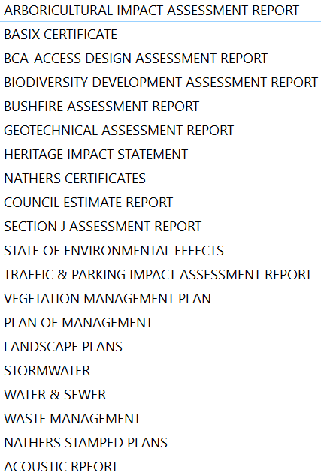  Architectural plans including perspectives also provided and material and colours details.
Clause 4.6 requests | None
Summary of key submissions | Localised environmental impacts including traffic generation, management of site access, impact upon biodiversity as site includes Robertson Basalt tall Open-forest and Robertson Rainforest (CEEC), impact upon heritage item, localised environmental impacts: noise, coach parking, construction matters, pollutants, stormwater management issues from site (photos provided) privacy impacts for neighbouring properties, extent of excavation and concerns about voracity of supporting reports (generally).
Report prepared by | Nancy Sample – Manager Development Assessment
Report date | 30/03/21  Revised 20/05/21
Summary of s4.15 matters  Have all recommendations in relation to relevant s4.15 matters been summarised in the Executive Summary of the assessment report? |  | Yes
Legislative clauses requiring consent authority satisfaction  Have relevant clauses in all applicable environmental planning instruments where the consent authority must be satisfied about a particular matter been listed, and relevant recommendations summarized, in the Executive Summary of the assessment report?  e.g. Clause 7 of SEPP 55 - Remediation of Land, Clause 4.6(4) of the relevant LEP |  | Yes
Clause 4.6 Exceptions to development standards  If a written request for a contravention to a development standard (clause 4.6 of the LEP) has been received, has it been attached to the assessment report? |  | Not applicable
Special Infrastructure Contributions  Does the DA require Special Infrastructure Contributions conditions (S7.24)?  Note: Certain DAs in the Western Sydney Growth Areas Special Contributions Area may require specific Special Infrastructure Contributions (SIC) conditions |  | Not applicable
Conditions  Have draft conditions been provided to the applicant for comment?  Note: in order to reduce delays in determinations, the Panel prefer that draft conditions, notwithstanding Council’s recommendation, be provided to the applicant to enable any comments to be considered as part of the assessment report |  | Yes

The proposal was considered by the SRPP at their meeting of 14 April 2021 and deferred by letter dated 20 April 2021 that requested additional information as follows:

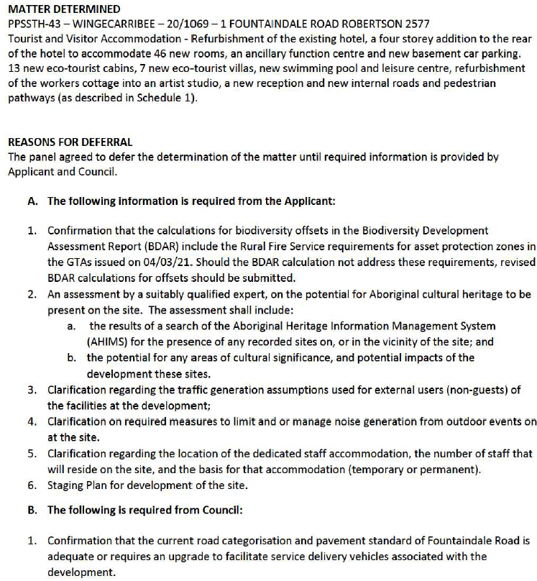
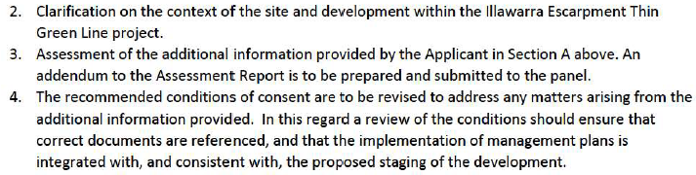

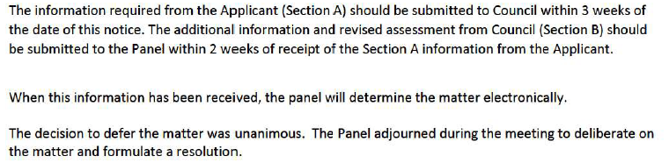

In regard to the requirement above, the proponent passed the information in response to Council within the timeframe requested by the Panel.

Council referred this information to relevant parties seeking advice and clarification. Due to delays in response to such referrals Council sought additional time to submit their assessment and response of one week. This additional time was granted.

Report – DA20/1069 – The Robertson Hotel

Introduction

On 20 March 2020, 20/1069 was lodged with Council seeking consent for Tourist and Visitor Accommodation - Refurbishment of the existing hotel, a four-storey addition to the rear of the hotel to accommodate 46 new rooms, an ancillary function centre and new basement car parking, 13 new eco-tourist cabins, 7 new eco-tourist villas, new swimming pool and leisure centre, Amphitheatre, animal petting area, refurbishment of the workers cottage into an artist studio, a new reception and new internal roads and pedestrian pathways.

The proposal is regionally significant development as identified in Schedule 7 of the State Environmental Planning Policy (SEPP) (State and Regional Development) 2011. It has a capital investment value (CIV) of over $30 million and therefore the Southern Regional Planning Panel is the determination authority.

Executive Summary

Recommendations in relation to relevant s4.15 matters as summarised:

The alterations and additions to the existing hotel and grounds (tourist and visitor accommodation as defined within the Standard Instrument LEP) included in the proposal are considered to be permissible in regard to Division 4.11 of the Act because, under Clause 4.67, the Regulation ‘may make provision for’ the alterations and additions proposed because under Clause 41 of the Regulation the existing use is not a ‘commercial use’ or a ‘Light industrial use’ as defined and is therefore not caught by the limitations (restrictions) in regard to part (2) of that Clause. Therefore, a significant intensification is permissible in regard to the existing hotel (tourist and visitor accommodation) use subject to consent.

In addition, the site is located within the E3 – Environmental Management zone under WLEP 2010 and the eco-tourist facility is a permissible use within that zone under WLEP 2010.

The potential impacts (environmental, social and economic) have been addressed by the proponent and satisfied concerns in regard to:

Bushfire Prone Land - Clause 4.46 of the Environmental Planning and Assessment Act 1979 has been addressed in regard to the proposal which comprises Integrated Development because the existing / proposed uses are to Bushfire Prone Land and therefore require the issuance of a s100B Authority under the Rural Fires Act 1997 has been addressed and the s100B Authority and conditions have been issued and form part of the draft conditions of consent.

Water Management - The proposal was also referred to Water NSW due to the works comprising a type that requires concurrence under SEPP (Sydney Drinking Water Catchment) 2011. Concurrence and conditions have been received.

Biodiversity - The site includes an area of Robertson Basalt Tall Open-forest and Robertson Rainforest in the Sydney Basin Region (Critically Endangered Ecological Community (CEEC)) and Upland Basalt Eucalypt Forests of the Sydney Basin Bioregion (Endangered Ecological Community (CEEC)) (BDAR / VMP provided with associated ecological review undertaken and found to be satisfactory subject to conditions) an Eco-walk is a key part of this proposal with the eco-cabins located throughout the site accessing pathways leading to this feature. Ecological advice has been received in regard to impacts under the Biodiversity Conservation Act 2016. It is noted that consideration under the Environment Protection and Biodiversity Conservation Act 1999 (EPBC Act) will be undertaken by the proponent further to the determination of this development application as agreed with the Australian Government- Department of Agriculture, Water and the Environment (Federal) because of proposed impact to the CEEC which is considered to be a matter of National Environmental Significance.

Heritage – The site is listed as a local item under WLEP 2010. The item has two reference numbers being I601 & I603. The heritage impact was considered in the assessment and considered an appropriate outcome for the site (heritage committee support given, and heritage advisor satisfied due to plans provided and conditions as recommended).
Traffic – Issues pertaining to SEPP (Infrastructure) have been resolved and TfNSW have provided their support and conditional requirements.

The proposal has been subject to two (2) periods of public notification and advertising resulting in public submissions. Concern was raised in regard to access to and from the site along with wider localised impacts. These matters have been addressed in terms of the assessment and approval subject to the imposition of conditions has been recommended to the panel.

Officers Recommendation

THAT the Southern Regional Planning Panel (SRPP) approve the proposed development application subject to the attached conditions and issue consent for the application DA20/1069 for Tourist and Visitor Accommodation - Refurbishment of the existing hotel, a four storey addition to the rear of the hotel to accommodate 46 new rooms, an ancillary function centre and new basement car parking. 13 new eco-tourist cabins, 7 new eco-tourist villas, new swimming pool and leisure centre, refurbishment of the workers cottage into an artist studio, a new reception and new internal roads and pedestrian pathways at The Robertson Hotel, 1 Fountaindale Road, Robertson, NSW 2577.

The redevelopment of this property has been a matter of discussion for a number of years and the main hotel building, being a locally listed heritage item, now showing signs of its age in terms of its appearance and structure.

The proposal forms part of wider strategy throughout the Wingecarribee Shire area which aims to improve tourist facilities and enhance the ‘visitor experience’ to the Southern Highlands. The proposal specifically meets the Highlands Destination Plan (economic development strategy) in regard to mid-week accommodation and conference facilities.

Accordingly, the proposal to increase hotel room numbers and cabins, provide ancillary facilities including a swimming pool and spa, install an ‘artist in residence’, provide private use of the mini-station access to the heritage railway to provide a ‘one-off’ tourist experience is supported.

The application includes construction staging that focusses initially on the bathrooms to the main building to ensure that the wedding business that is already provided by the existing Hotel building can continue as booked.

Given the location of the existing Hotel and the generous setbacks despite the rear addition and other new elements, we request that SRPP approve the development subject to conditions.

Subject Property and Surrounding Area

The site is known as No. 1 Fountaindale Road, Robertson, described as Lot 2 in DP610676.

The subject site is bounded by the Illawarra Highway to the north and north-west, a railway line to the east and south-east and Fountaindale Road to the west and south-west.

The site is an irregular (droplet) shaped parcel of land, with a combined north and north western frontage to the Illawarra Highway of 319.529 metres, a combined eastern and south eastern boundary of 340.286 metres and a combined southern and south western frontage to Fountaindale Road of 198.713 metres, providing a total site area of 5.06 hectares.

The site is highly vegetated with a blend of native and exotic trees and vegetation located throughout the gardens /grounds. The site is characterised by vegetated setbacks on all sides and the main hotel building is not visible from the street frontage.

Access to the site is via a setback ‘gate’ and via a driveway looping into and under the portico of the main hotel building. There is also a separate loop behind the hotel adjoining the main access road via main gateway.

Please refer to information and images in Figures 1 and 2 below:
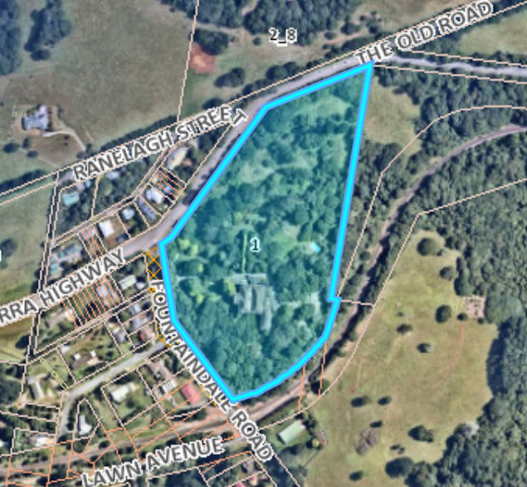
Figure 1: Site Location plan with overlay

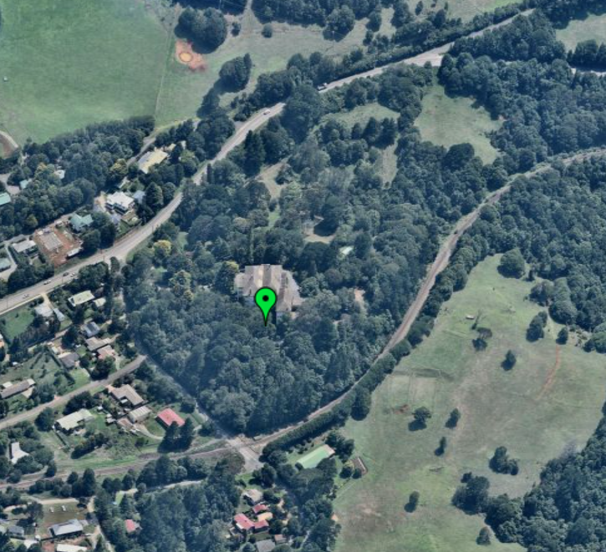
Figure 2: Aerial Photo from Nearmap
The hotel is located upslope from the main entrance by approximately 10m and includes a significant fall from that high point on the site towards the rear (south eastern side) as shown below on the contours mapping extract from Council’s GIS. The contours below are 5m intervals.

The site includes a natural valley (flow path) leading from the mid-section of the north eastern section of the site as shown on the contour mapping provided in Figure 3.

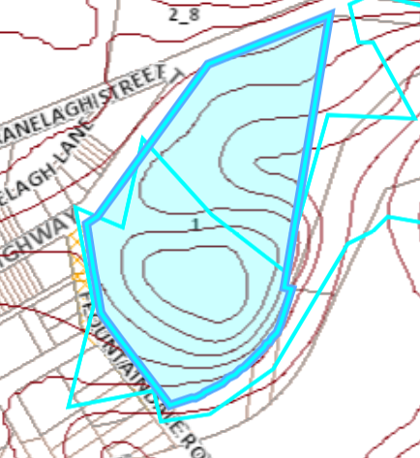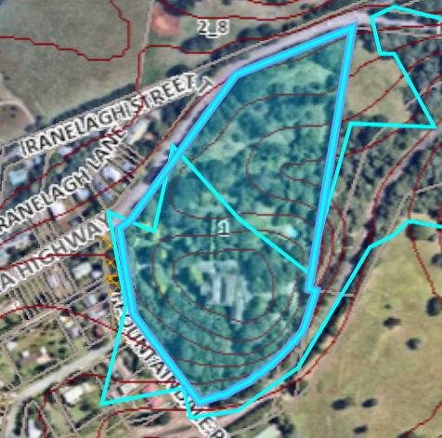
Figures 3: Contour mapping and Nearmap overlay

Access to the property is currently provided by a front gate and driveway from Fountaindale road and an internal driveway provides for drop off to the front hotel portico and access to rear and side parking areas and an access driveway.

It is also noted that there is a dilapidated track to a platform to the railway that runs through Robertson (non-main line passenger -used for heritage trains and freight only).

The property currently includes:
- 49-bedroom heritage listed hotel building;
- Workers cottage (dilapidated state);
- Grotto;
- Tennis Court;
- Extensive landscaped grounds including areas for birds and horses (miniatures);
- Outdoor pool;
- Large Pond;
- Dams;
- Outbuildings and aviaries (coops).

Property Burdens and Constraints

Burdens – There are no legal burdens that would preclude the development as proposed.

Constraints – The site is constrained as follows:

Heritage –

The property is a locally listed heritage item under Schedule 5 of the WLEP 2010 as follows and shown in Figure 4:

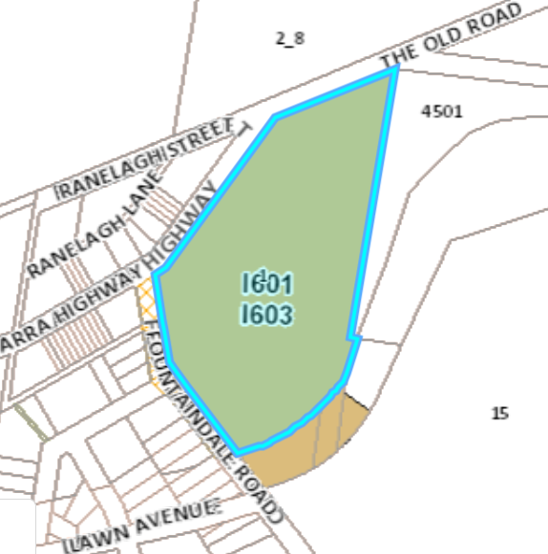
Figure 4: Heritage layer - Extract from Council GIS system

Bushfire Prone Land –

The site is entirely bushfire prone land (see Figure 5). Accordingly, the proposal comprises a Special Fire Purpose under the Rural Fires Act and therefore comprises Integrated Development as considered previously in the Executive Summary.

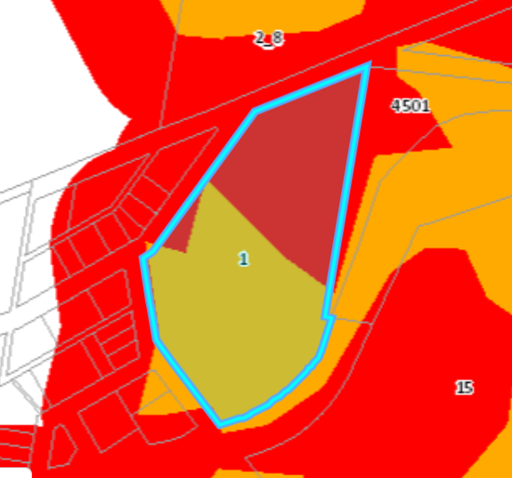
Figure 5: Bushfire Prone Land layer -Extract from Council’s GIS
Biodiversity –

The site is mapped as including Robertson Basalt tall Open-forest (CEEC) and Robertson Rainforest (CEEC) and therefore must be considered under Clause 7.4 Natural Resources Sensitivity – Biodiversity. Due to the woodland types affected, the proponent has been liaising with Federal Government in regard to the future referral of any consent under the EPBC Act for relevant consideration at that level.

It is noted that the WLEP 2010 mapping associated indicates that the land is not Riparian Land nor is it part of an identified Regional Wildlife Corridor. Refer to mapping extract below (Figure 6) identifying approximate area of CEEC (this has been considered in detail by external ecologists – as considered later in this report).

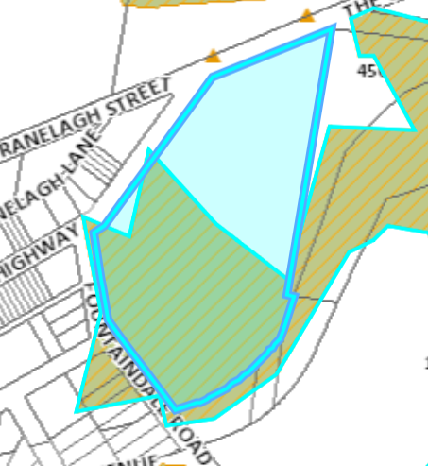
Figure 6: Approximate Extent of Woodland (CEEC) mapped on Council GIS across the site

The size of the site exceeds 1ha and the proposal includes a vegetation clearing level / impacts that triggered the requirement for a Biodiversity Development Assessment Report (BDAR) to be submitted with the application. The Biodiversity Values Map (see Figure 7) (NSW State Government) indicates the values (biodiversity) to the site being located to its southern side.

Accordingly, the proponent submitted a BDAR, Arborist Report, Vegetation Management Plan and Landscape Plans and a Bushfire Report with the originally submitted plans. The proponent updated the BDAR further to a request from Council and the outcome was further scrutinized by an independent ecologist to ensure the voracity of the proposal.

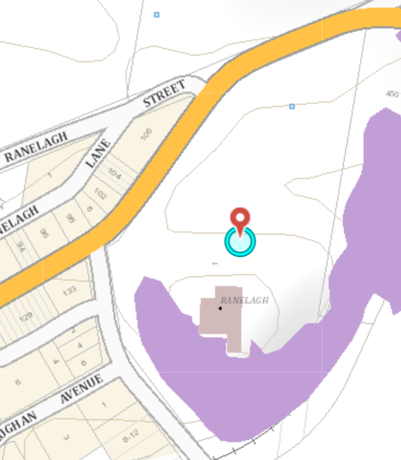
Figure 7: Extract from NSW State government – Biodiversity Values Map

Proposed Development

On 20 March 2020, 20/1069 was lodged with Council seeking consent to Tourist and Visitor Accommodation as described previously in this report.

The updated ‘master plan’ for the site is shown below in Figure 8:

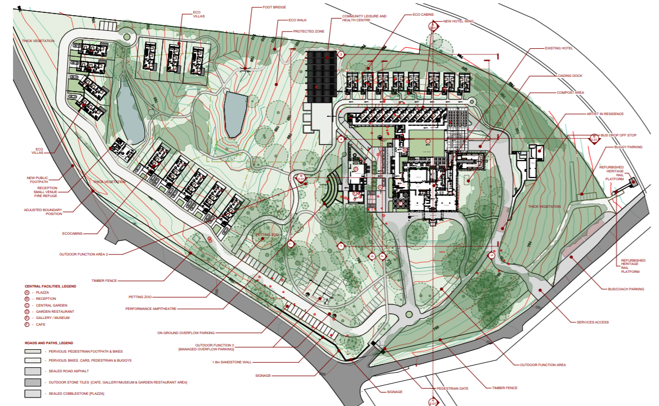
Figure 8: Master Plan for site
Description of extent of works proposed including extracts from SEE:

- An upgrade of the existing hotel building, including an increase in hotel rooms from 49 to 95 rooms, improved internal access and provision of recreational spaces and conference facilities ancillary to the hotel use. This upgrade is detailed below:

  - Extensive renovation of the heritage hotel, including new lifts, kitchen and service area, additional bathrooms, and new rooms in the roof area;
  - a four-storey addition to the rear of the hotel to accommodate our storey addition at the rear of the existing hotel, including 46 new accommodation rooms, new lounge areas, bar, restaurant, function rooms and conference spaces;
- Integrated basement car parking for 156 cars;
- 13 x two storey temporary/short term eco-tourist cabins at the northern and eastern sides of the site - each containing four rooms and designed to allow for flexibility in accommodation types. The five cabins at the northern extent each have two car parking spaces and a private courtyard;
- 7 x three storey eco-tourist villas located at the northern side of the site - each containing four bedrooms, a private courtyard and car parking space;
- Swimming Pool and Leisure Centre associated with and ancillary to hotel;
- The existing studio and workers’ cottage located within the southern portion of the site to be refurbished for use as an ‘artist-in-residence’ studio and cottage associated with the hotel and local (highlands) artists.

- The emphasis is on the provision of a broader range of accommodation types that are flexible in design, so they can be reconfigured for a multitude of groups (ranging from corporate visitors, singles to large families);

- New internal roads and at-grade overflow parking;

- New bus and coach parking area at the south eastern corner of the site off Fountaindale Road;

- Separate service entry off Fountaindale Road;

- Refurbishment of the existing heritage rail platform (later stage of works and dependant on arrangement with ARTC who have not yet given full advice on final plans (refer to consideration of referrals).

- Provision of more outdoor recreation facilities ancillary to and managed by the hotel including the retention (relocation) of the existing Grotto (heritage and religious values), extensive landscaping of garden areas, petting zoo, amphitheatre, outdoor function area;

- Opening up outdoor facilities for public use, by arrangement with the hotel. The use of the pool by Robertson residents is a matter that the proponent is supportive of. The Plan of management associated will refer to this by condition to ensure that this matter is enabled as proposed;

- Promotion of local art and culture; and

- Creation of new pervious pathways to activate the unbuilt heritage environment and provide greater access to the landscaped areas of high heritage and ecological value (including Eco walk).

Applicants Supporting Statement

The proposal is supported by a Statement of Environmental Effects (SEE) prepared by GSA Planning dated 20/03/20.

In regard to employment generation and management, the SEE states:

‘The proposed development will operate 7 days per week, 52 weeks per year. The hotel operational hours will be 9:00am and 5:00pm Monday to Friday and 9:00am and 5:00pm weekends and public holidays. The ancillary leisure facility will operate between 8:00am to 5:00pm Monday to Friday, 8:00am to 8:00pm on Saturday and 8:00am to 5:00pm on Sunday. While the hotel currently employs approximately 13 regular staff, it is expected that the proposal will employ 50 full-time, casual and part-time staff. Additional staff may be required for larger events and weekends. Staffing and rosters will vary during peak and off-peak periods. The proposal will provide staff accommodation within approximately 20 dedicated rooms, for staff living on-site. Both during and outside of operational hours, the hotel will have personnel on-site or on-call to manage the hotel…’

Accordingly, the proposal generates an additional 37 local jobs thereby meeting aims of WLEP 2010, Robertson Village DCP in regard to employment generation.

It is noted that further information is supplied within the Plan of Management supplied in support of the application. The hours of operation are sympathetic to the surrounding area and neighbouring residential uses and weddings (which are noise generating functions) have been part of the business model for the hotel for years with no unreasonably negative localised environmental impacts to the surrounding areas. Such uses assist the Southern Highlands to attract tourism throughout the week, not solely during weekends. This is part of the focus for our local economic development strategy known as the Destination Plan as referred to in the Executive summary.

The Statement of Environmental effects provided is of a high standard and considers relevant aspects of the development. The proposal is supported by a selection of perspectives included as an attachment to this report that enable the scale to be considered. The architect has developed an electronic model that has been used during the site inspections to illustrate the relative size and scale of the buildings across the site. One of these is included below (Figure 9), showing the view from the proposed restaurant building looking into the courtyard area with new hotel wing to the left-hand side. It illustrates the relative scale.

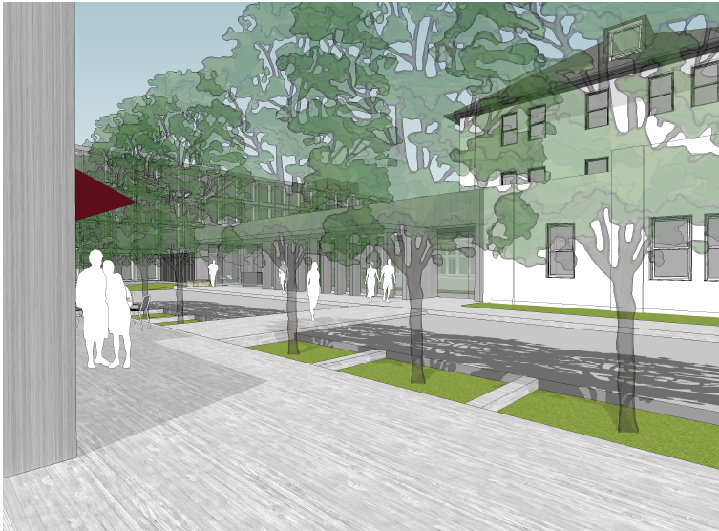
Figure 9: View from proposed restaurant area (referred to as plaza)
Contact with Relevant Parties

An extensive site inspection was undertaken on 01/09/2020 with Council’s assessment officers, the owner and the planning consultant / architect. A separate site inspection was undertaken by Council’s heritage advisor and relevant heritage committee members. The liaison with the proponent has been an iterative and fluid process enabling timely responses to questions from both parties and liaison regarding Agency responses via the Planning Portal.

Photographs of the site are shown in Figures 10-23 below:

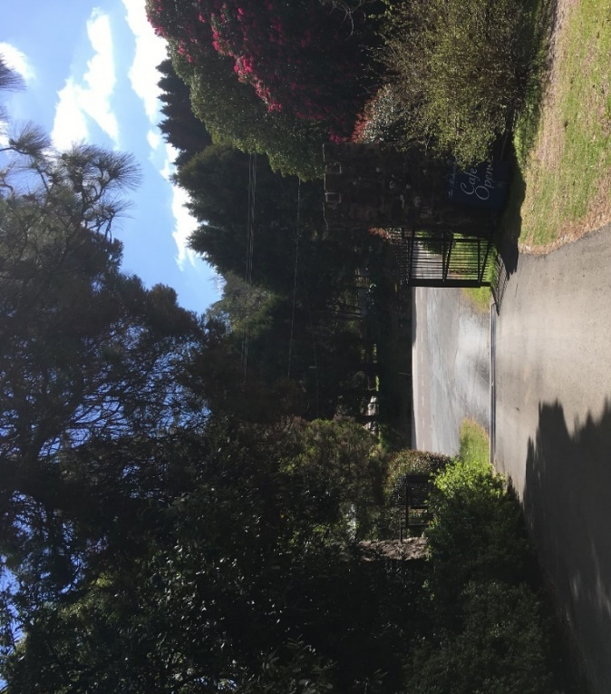
Figure 10: Existing gateway / entrance (view towards street)

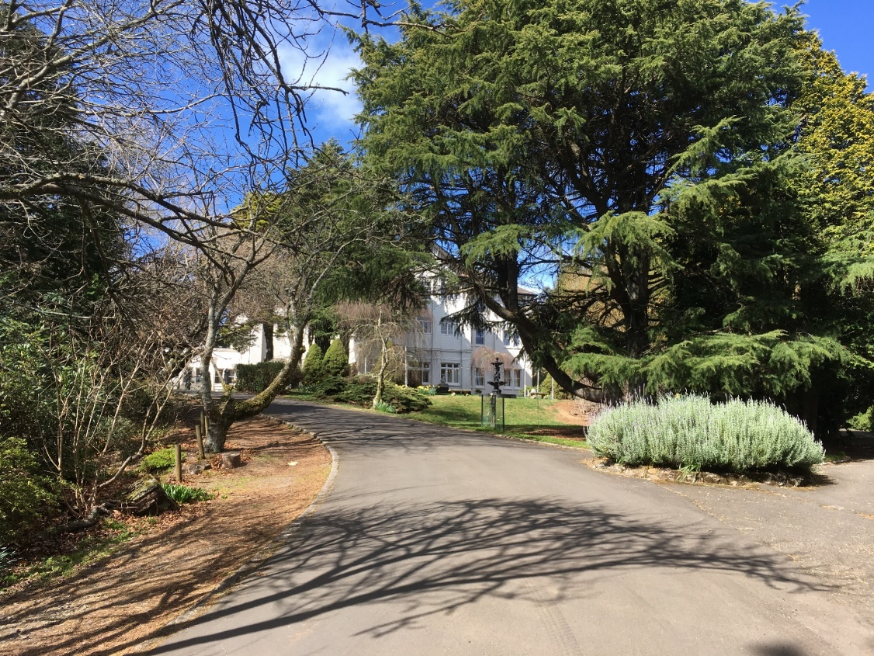
Figure 11: View from gateway to main hotel entrance

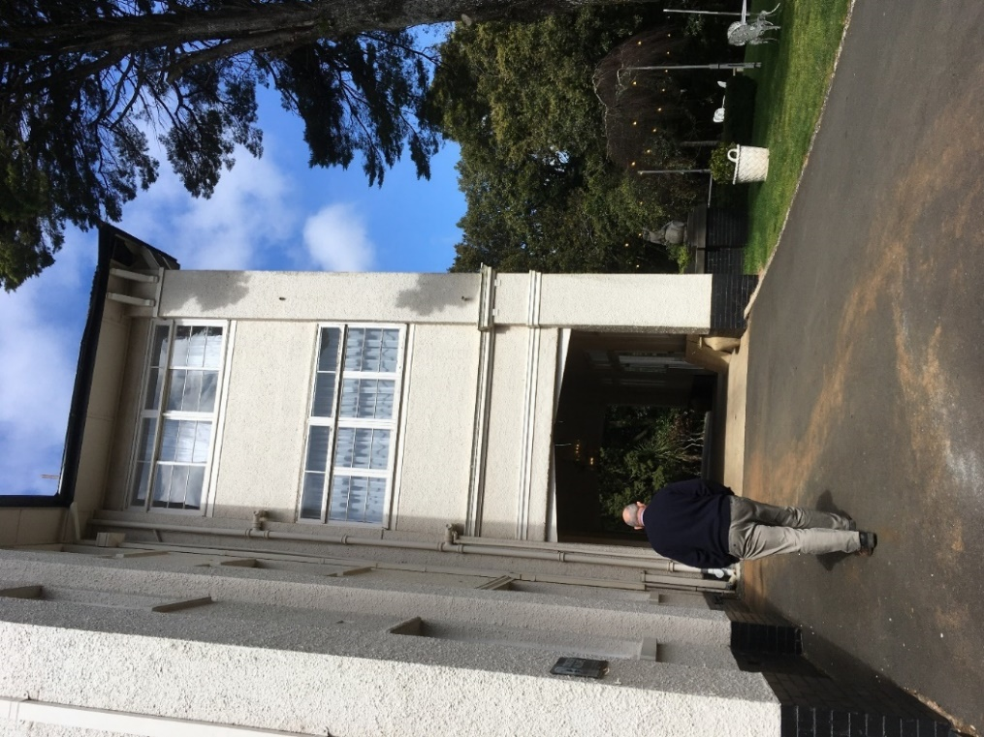
Figure 12: Front entrance portico

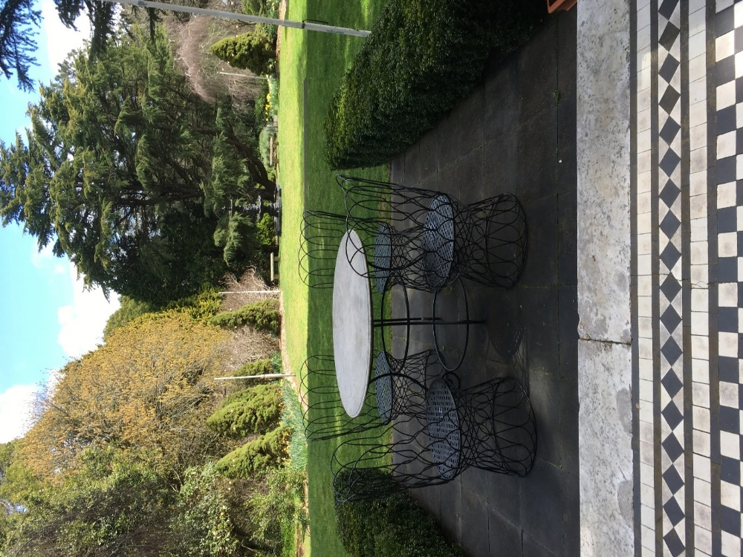
Figure 13: View from front seating area towards gateway

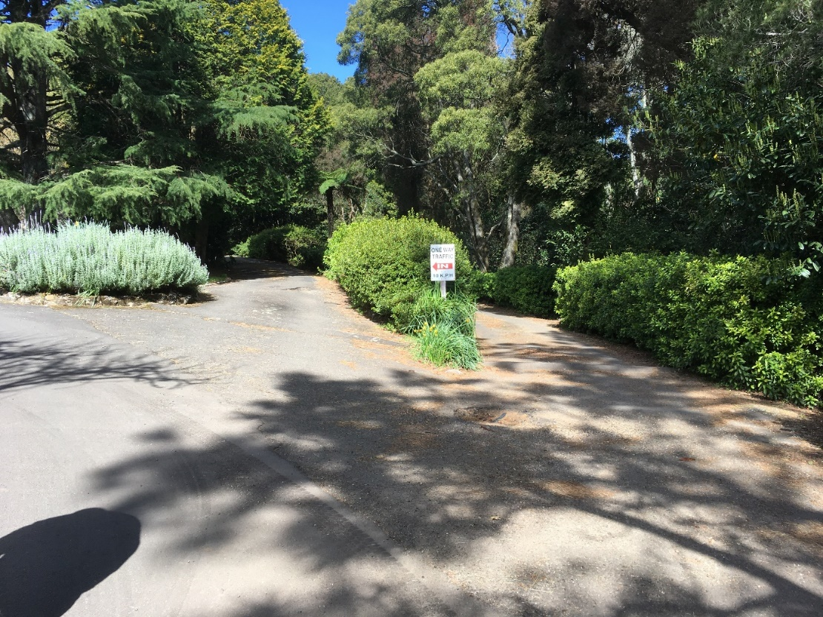
Figure 14: Entrance/exit to existing rear access road around the back of the hotel

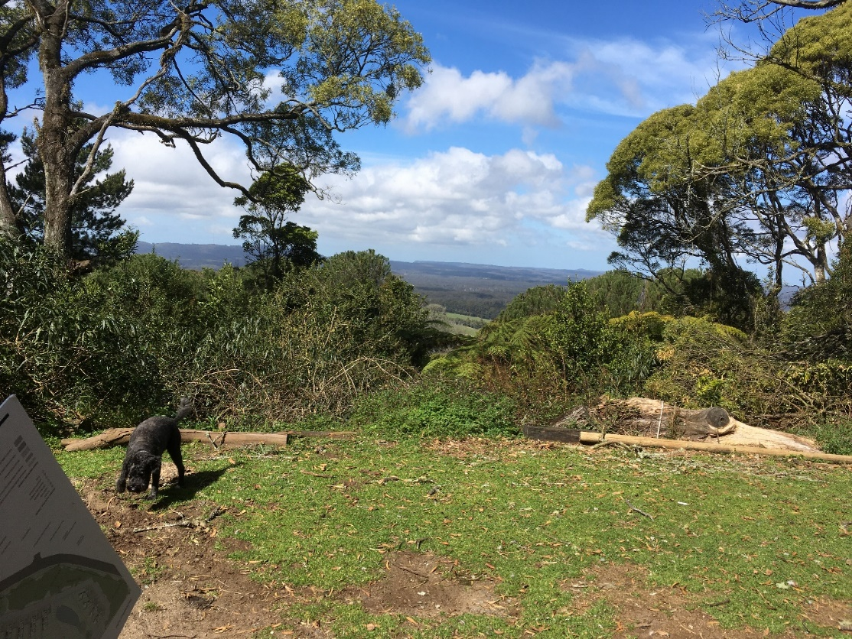
Figure 15: View from escarpment

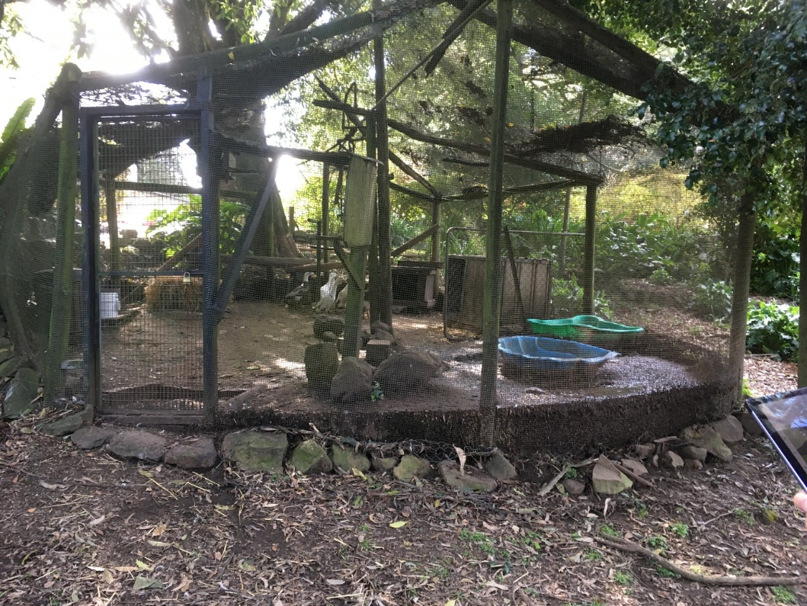
Figure 16: Existing coop (for geese) (one of a number)

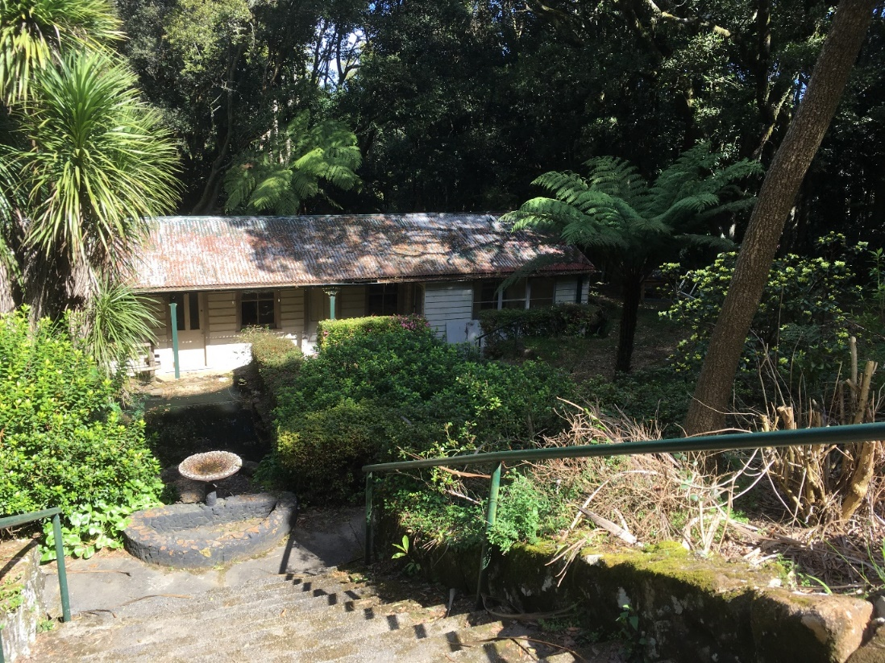
Figure 17: Existing ‘craft cottage’ to be renovated and converted into studio space for use by an ‘artist in residence’

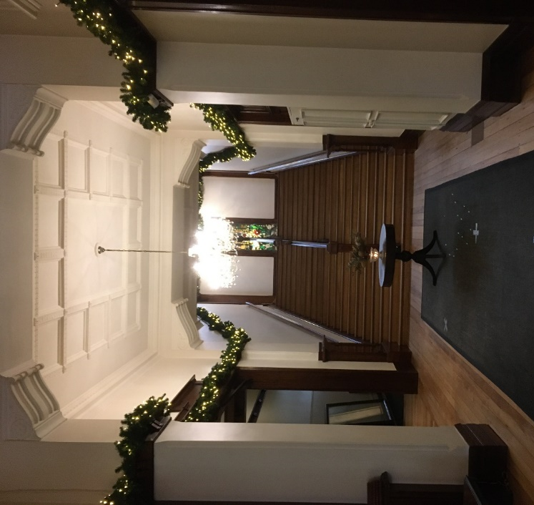
Figure 18: Existing Entrance Hallway

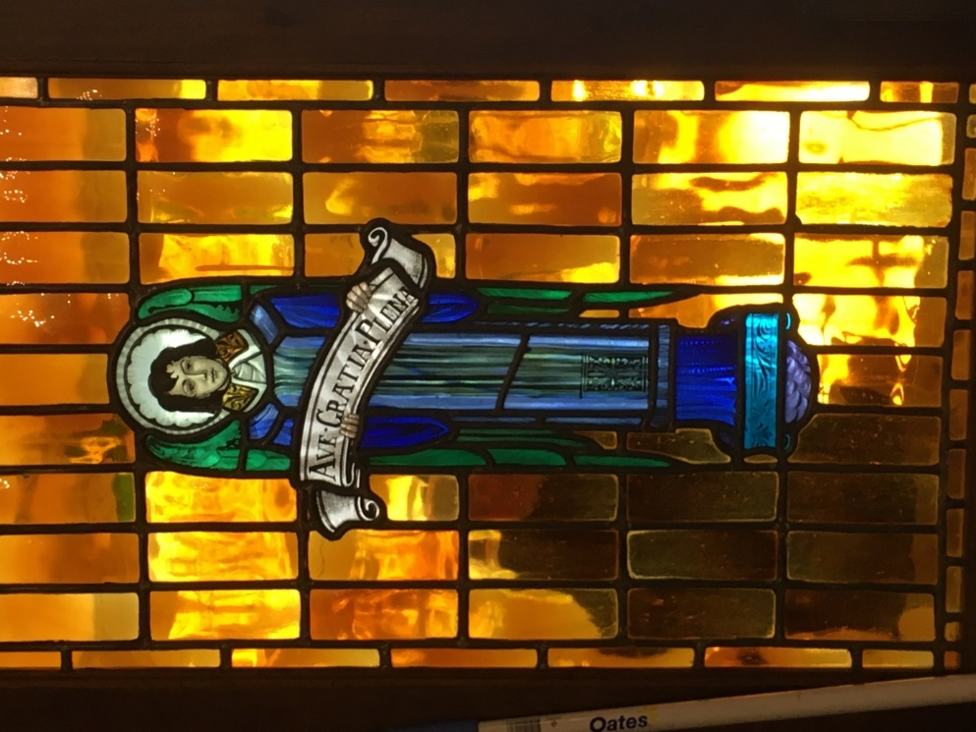
Figure 19: Example of stained-glass window insert as recommended to be retained within the development (by condition)

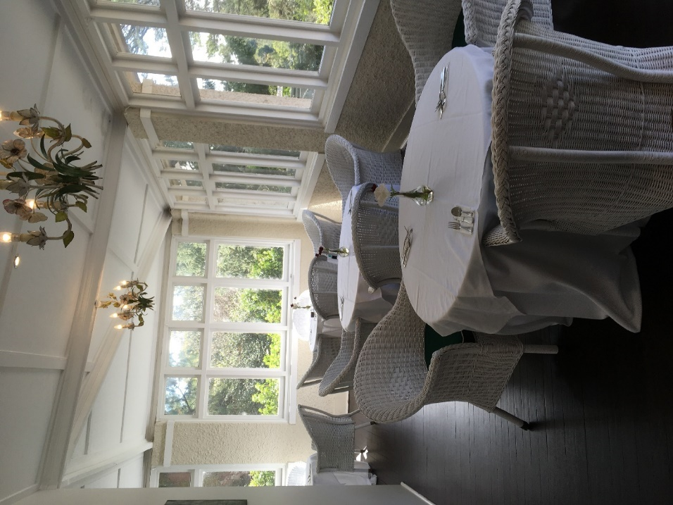
Figure 20: Existing sun room area (breakfast room) to ground floor level

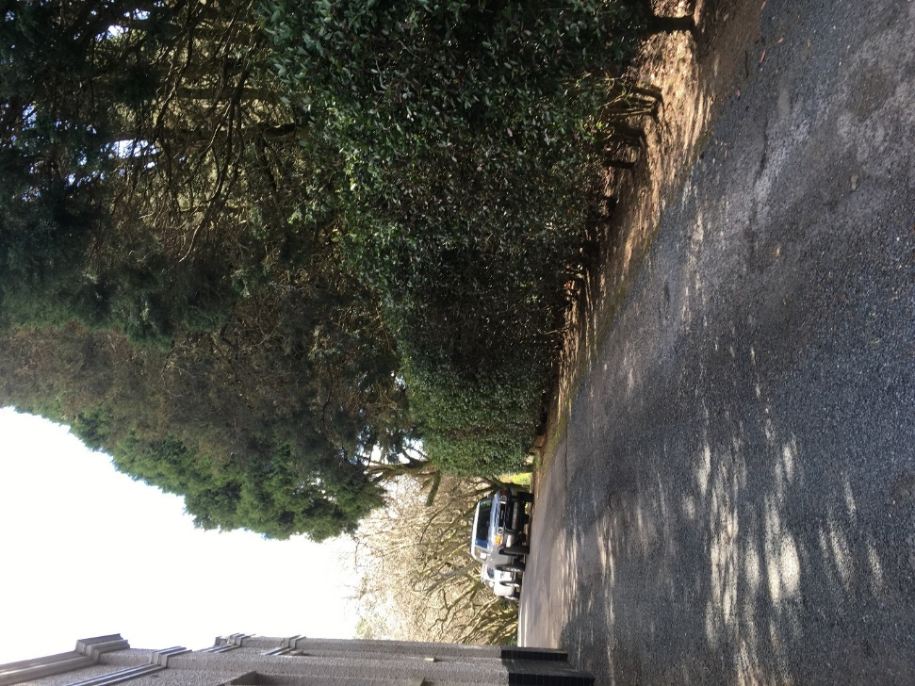
Figure 21: Car access along eastern side of hotel – trees currently reaching same height as hotel to this side

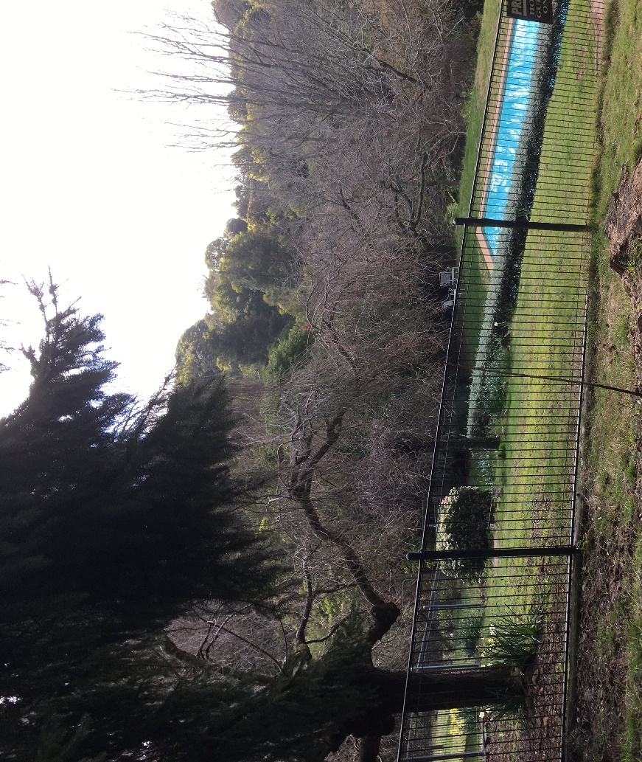
Figure 22: Existing Outdoor Pool

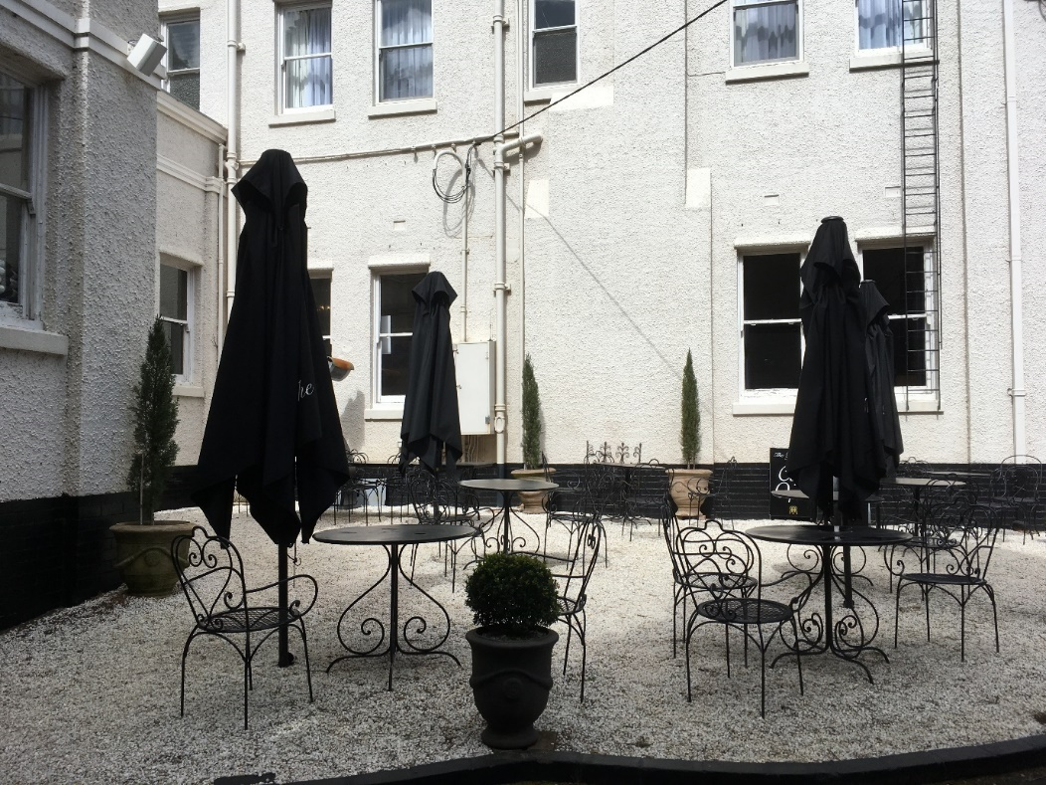
Figure 23: Existing al fresco café area to eastern side of hotel

Public Submissions

The development application was advertised and notified to surrounding properties between 15/05/2020 to 22/06/2020 and thirty-four (34) submissions were received. It is noted that most of the submissions received supported the proposal subject to key issues being managed.

Key issues included concerns about traffic impacts, management of safe access to and from the site and protection of the biodiversity values to the site.

The development application was re-notified between 13/01/21 and 18/02/21 and 10 submissions were received.

The issues raised within the submissions are considered below:

Issue | Response | Condition / not condition
Support and consideration that the proposal will bring tourists into the area and be good for area. | Noted | N/A
Traffic and Parking Impact report incorrect in regard to the train station as it is only 5m dilapidated platform and also nearest bus stop 1km away and poor access to public transport. | The traffic aspects have been considered by both TfNSW and Council’s Traffic team who, further to the receipt of amended plans and ongoing discussions with the engineers engaged by the proponent are satisfied and have issued recommended conditions of consent. | Yes
Impact from excavation and Water table disturbance | A geotechnical report was submitted and has been reviewed by councils’ engineers and Water NSW who have issued their concurrence for this proposal. Plans were amended as part of this process further to a request from Council’s engineers regarding the management of stormwater and water through and across the site. Amended plans were submitted that now meet the requirements of Council and Water NSW in regard to this issue subject to the imposition of recommended conditions of consent. | Yes
Increased traffic impact and pedestrian safety | The traffic aspects have been considered by council engineers and the TfNSW and found to be satisfactory subject to conditions. | Yes
Negative impacts to heritage building and gardens with watering system set up by monks | Heritage aspects have been considered and found to be reasonable subject to the imposition of conditions as recommended. | Yes
Power outages and phone signal poor in parts of Robertson | This is not an assessment issue; the owner will manage risks in regard to power management and phone signal. There are standard conditions in regard to any upgrading of connections as required. | Yes
Risks due to presence of asbestos in particular craft cottage | Standard condition recommended requires licenced contractor to remove any asbestos as required by legislation. | Yes
Proposal not suitable for area and excessive in scale and impacts | The proposal has been considered against relevant controls and found to be reasonable in its context and it has been noted that the highly vegetated site with highly vegetated borders will minimise visual impacts and the underground car parking will minimise acoustic impacts from car management as it is enclosed. | N/A
Claims in regard to public transport access are incorrect | The issue of access to public transport is not a matter that would preclude the development as proposed because while such use is supported, the development does not rely upon it. The site is characterised as being ‘visitor and tourist accommodation’ under the WLEP 2010. As such, it is recognised that | N/A
Geotechnical report inadequate | While concerns are noted, the advice received from qualified geotechnical engineers has been provided. A development application is a conceptual approval for a scheme. Final engineering details and advice will be provided with the construction certificates issued for the works. Any development of this scale requires an iterative and ongoing approach to reports and site development. Council recognises this and therefore has considered the application accordingly. | Yes
Residential privacy and impacts to Fountaindale Road | This aspect has been considered and the panel members and Council have undertaken detailed site inspections. This report recommends the approval of this application subject to the imposition of conditions and a plan of management. | Yes
Impacts to rainforest and vegetation | The proposal has been supported by a BDAR (as revised) and an arboricultural report and a vegetation management plan. Council also engaged an independent ecologist to undertake two review of the information submitted. The outcome was support for the proposal subject to the imposition of conditions. The proponent has been liaising with the Australian Government- Department of Agriculture, Water and the Environment and will refer their proposal under the EPBC Act further to the issuing of any future consent as required by Australian Government- Department of Agriculture, Water and the Environment. | Yes
Voracity of eco cabins i.e. concerns they will have negative environmental impacts | The eco cabins and villas do have design features such as slot side windows to reduce reliance on power. They are design simply but must meet standards required for accommodation. The construction plan includes retention of as many trees as practicable to the site with the cabins/villas being ‘sacrificial’ as the RFS required a refuge to be provided as part of this design feature. I.e. the choice was made to retain vegetation over structures with a higher BAL rating. | Yes
Impact of Amphitheatre on residential amenity | Conditions are recommended to protect surrounding amenity and limit what can be undertaken at the Amphitheatre and exactly how e.g. no amplified music or sound and restricted times and types of use. | Yes

Referrals & Responses

Internal Referrals:

- Accredited Certifiers – No objections and referral received including recommended conditions.

- Development Engineers – No objections and referral including recommended conditions.

- Environmental Health Officer – Request for information was sent to the proponent dated 11/06/20 requesting the following:

‘Submit an Acoustic Assessment Report for the proposed development. The Report is to meet the following requirements:
- be prepared by a duly qualified acoustic consultant who is a full member of either the Association of Australasian Acoustical Consultants (AAAC) or Australian Acoustical Society (AAS);
- comply with the AAAC guidelines AAAC Guideline for Licensed Premises v1 - July 2019 and AAAC Guideline for Report Writing V2.0;
- consider all likely noise sources, including, but not limited to:
  - plant and equipment;
  - amplified music;
  - public address system;
  - garden wedding ceremonies, including pre- and post-ceremony drinks;
  - patrons (including arrival and departure);
  - staff (including their arrival and late departure);
  - waste management, including handling of empty glass containers during functions as well as waste collection; and
  - vehicle movements.
- make realistic assumptions about the noise emanating from the premises and consider the worst case noise scenarios. Please note that unrealistic assumptions such as “there will be no noise because patrons will be advised to keep the noise down” and the like will not be accepted by Council.’
Subsequently, an acoustic report was supplied evidencing that the acoustic requirements can be met subject to conditions. The EHO provided conditions that have been included in the draft notice of determination provided at Attachment 1.

- Heritage Advisor/ Heritage Committee – No objection to proposal from Heritage Committee. Councils External Heritage consultant responded on 04/08/20 requesting that the following items be provided. These are considered below:
- ‘External finishes sample board - image showing typical external materials, profiles, finishes and colours e.g. new roof material to original building. (discussed on site, agreed and as I recall prepared, but cannot find in current plans).’
These have been provided and agreed.
- ‘Grotto - photo record, plans of replacement grotto sculpture and paths etc. leading to it. (I recall seeing details but cannot find them in current plans).’
A condition has been recommended in regard to the photographic recording of the history and physical aspects of the existing grotto for future reference. The grotto – as relocated – has been included on plans – refer to Figure 24 below (extract from Dwg 1.01 provided in the set of plans accompanying this application).
Figure 24: Extract from Dwg 1.01 indicating Grotto
- ‘Accommodation block roof gardens/vegetation - discussed on site, agreed, depicted in green on perspectives but cannot find landscape details.’
Landscape details provided and agreed now included in accompanying set of plans.
- ‘Historic stained-glass windows - to be reused in renovation of the dining room.’
A condition has been included requiring this due to historical value of the stained glass and link to the Hotel.
- ‘"Craft Cottage" - retain, repair (or reconstruct to match existing) and reuse.’
This is being retained, repaired sympathetically and re-used for an ‘artist -in residence’ who will provide art work for the Hotel and Southern Highlands and beyond. The proponent recognises that the building as repaired may not be suitable as accommodation and therefore the artist will reside within part of the hotel but work in this building. Accordingly, it will be used as an artist’s studio.
- ‘Gateway - retain or adapt sympathetically.’
The amended plans include the retention of the Gateway and the proponent has repeatedly advised of the intention to retain the Gateway.
- ‘Area of relict rainforest trees - retain and interpret (e.g. small explanatory sign).’
The proposal includes the management of an existing area of Robertson Basalt Rainforest (CEEC) and other CEEC types and the retention of the majority of the area as evidenced through the supporting reports and advice from an independent ecologist. The advice from the ecologist is included as an attachment to this report. It is also noted that any consent must be referred to Federal Government under the EPBC Act for further consideration and that requirement forms part of the draft consent provided with this report. The interpretive signage requirement has been included as a consent requirement subject to approval by Council (artwork etc) prior to the issue of any occupation certificate for the relevant stage of the development.
- Contribution Planner – No objections subject to the imposition of developer contributions under the Act. These form part of the draft set of conditions within the draft Notice of Determination.

- Water and Sewer Officer – No objections subject to the imposition of conditions that have ben included in the draft Notice of Determination.

External Referrals/Liaison:

Federal Government

- Australian Government- Department of Agriculture, Water and the Environment – Liaison with this department has been undertaken to ensure voracity of assessment process in regard to impacts to the Robertson Basalt Tall Open-forest (CEEC) and the and Robertson Rainforest (CEEC) and all relevant biodiversity impacts. The proponent has also been liaising in good faith with this department and agreed to formally refer the proposal under the EPBC further to determination (as required).

State Agency:

- TFNSW – Transport for NSW

This Agency responded as follows – 11/03/21:

‘…TfNSW has completed an assessment of the DA, based on the information provided and focussing on the impact to the state road network. TfNSW notes for this DA:
• The key state road is the Illawarra Highway;
• Council is seeking advice from TfNSW to assist in its assessment under Clause 101 of State Environmental Planning Policy (Infrastructure) 2007; and
• The proposed access arrangements shown in Attachment 1.

Having regard for the above, TfNSW will not object to the DA subject to the conditions outlined in Attachment 2 being included in the conditions of development consent.

TfNSW highlights that in determining the DA under Part 4 of the Environmental Planning and Assessment Act, 1979, it is the consent authority's responsibility to consider the environmental impacts of any road works which are ancillary to the development. This includes any works which form part of the proposal and/or any works which are deemed necessary to include as requirements in the conditions of development consent. Depending on the level of environmental assessment undertaken to date and nature of the works, the consent authority may require the developer to undertake further environmental assessment for any ancillary road works. Upon determination of this matter, it would be appreciated if Council could send a copy of the Notice of Determination to development.southern@rms.nsw.gov.au.’

- RFS – Rural Fire Service

This Agency responded as follows – 04/03/21:

‘This authority supersedes the previous Bush Fire Safety Authority DA20200528001878-Original-1 issued on 06/07/2020 and confirms that, subject to the attached reissued General Terms of Approval being met, the proposed development will meet the NSW Rural Fire Service requirements for Bush Fire Safety under s100b of the Rural Fires Act 1997.’

- Water NSW

This Agency responded as follows- 01/02/21:

‘..Based on the site inspection and the information provided, Water NSW is satisfied that the proposed development, as amended, can achieve a neutral or beneficial effect on water quality provided appropriate conditions are included in any development consent and are subsequently implemented.

If, after receipt of this letter, revisions are made to any of the DA plans, Council does not need to refer the plans to Water NSW if the revisions will have no impact on water quality. Council is requested to amend the relevant Water NSW condition/s to reference the revised plans and notify the assessing officer by email…

Water NSW concurs with Council granting consent to the application subject to the attached conditions. This advice replaces previous advice issued to Council on 23 November 2020.’

- ARTC – Australian Rail Track Corporation

This Agency responded as follows – 27/11/20:

A response marked as ‘confidential’ was sent to Council and issues therein as required and found to be applicable are addressed through recommended conditions of consent. The author is this report has respectfully recognised the request that the letter be treated in confidence and is therefore not including extracts in this report.

The Agency further responded on 17/06/21 as follows:

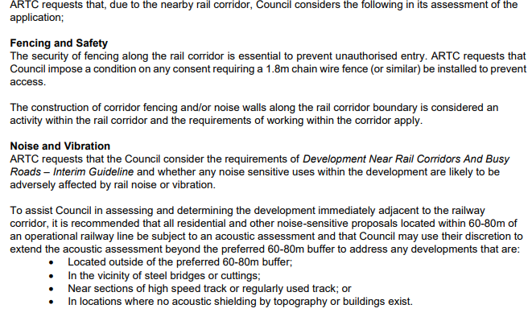
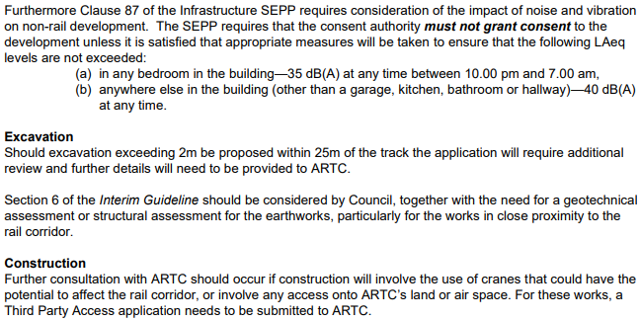

The comments are noted, and the conditional requirements included within the draft Notice of Determination accompanying this assessment. It is noted that this advice was provided further to much consideration of the matters within the application and some of the requirements within this referral response are found to be based upon residential requirements when the application relates to a hotel and visitor & tourist accommodation which is therefore not caught by Clause 87 of SEPP infrastructure. Council’s Environmental Health officer has provided detailed considerations and conditions relating to acoustic matters and management for this project. Council is satisfied that acoustic matters have been considered.

The access to the ail corridor has been in place for decades and it is not considered reasonable or necessary to impose fencing requirements upon this existing hotel.

It is noted that no excavation is proposed within 25m of the tracks is proposed. Any such excavation would require a modification to be submitted under s4.55 of the Act and would also require referral to the ARTC for detailed consideration. Accordingly, the conditional requirements will not be imposed upon this consent as they are not considered to be required.

External

- Ecologist (Tree and vegetation)

This specialist responded as follows – 16/11/20:

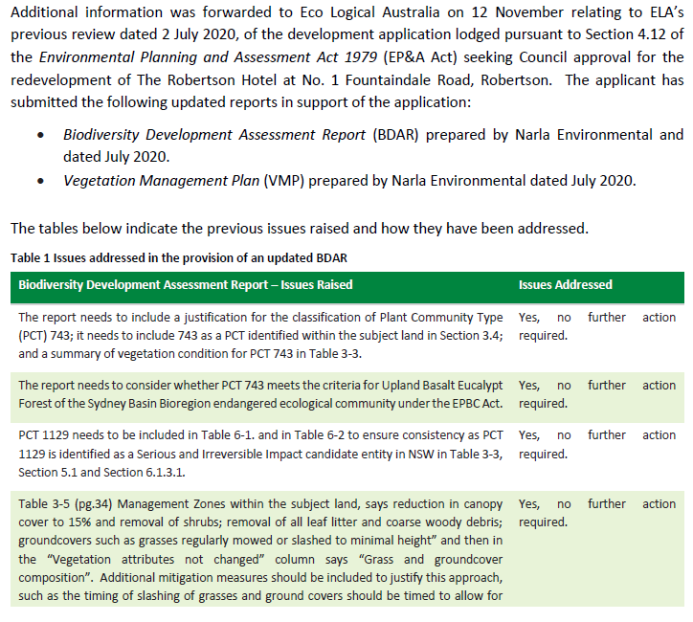
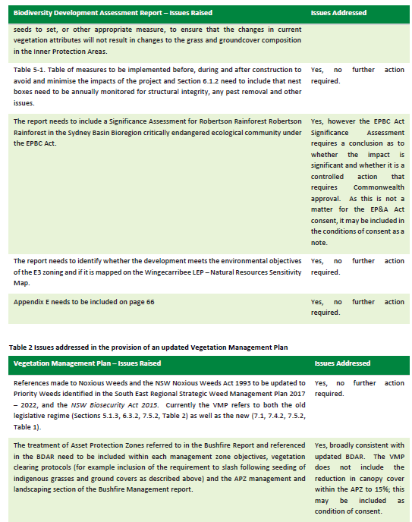

The outcome of this second review of the BDAR and supporting information was considered a satisfactory outcome and conditions as recommended have been included in the draft consent.

The updated BDAR and previous advice from the ecologist above is included as an attachment to this report. The requirement for the proponent to formally refer their application (after any consent issued where that is the case) to the (Federal) Australian Government- Department of Agriculture, Water and the Environment regarding consideration of the EPBC Act is included in the draft conditions of consent included in the draft notice of determination.

Planning Assessment

Environmental Planning and Assessment Act 1979 Section 4.15

In determining a development application, a consent authority is to take into consideration such of the following matters as are of relevance to the development the subject of the development application:

(a) the provisions of:
(i) any environmental planning instrument, and

State Environmental Planning Policy (Sydney Water Catchment) 2011
The proposal is of a type that triggered referral for concurrence from Water NSW. The concurrence has been ascertained subject to conditions forming part of the draft consent.

State Environmental Planning Policy (Building Sustainability Index: BASIX) 2004
Corticates have been submitted as required in support of this application.

State Environmental Planning Policy (Infrastructure) 2007
The provisions of SEPP (Infrastructure) 2007 have been considered in the assessment of the development application.

The application was referred to the RMS (TfNSW) for comment under Clause 101 because the site fronts a Classified Road. The proposal is also considered to be Traffic Generating Development under Clause 104 of the SEPP and considered in Schedule 3 as ‘any other purpose’ having a traffic generating rate of more than 50 vehicles per hour. TfNSW have provided their support subject to conditions for the proposal.

The proposal was also referred to the ARTC under Clause 85 of the SEPP due to the proximity of the rail corridor and due to the proposed potential use of the mini platform for tourists / hotel guests (if supported) to access the hotel from heritage trains that use the line (should this be enabled in the future). ARTC have provided their broad support and comments subject to conditions and further consideration of issues.

State Environmental Planning Policy (Koala Habitat Protection) 2020
A koala report was submitted with the application as considered by the ecologist engaged by Council to review the proposal. No issues were raised in regard to the site comprising core koala /potential koala habitat. None of the submissions have raised any concerns in regard to any specific koala habitat.

State Environmental Planning Policy No.55 -Remediation of Land
The aim of SEPP 55 is to ensure that a change of land use will not increase the risk to health due to the excavation or management of land. In this case, the land is not identified as potentially including Acid Sulphate Soils. Clause 7 of SEPP 55 requires the consent authority to consider whether land is contaminated prior to granting consent to the carrying out of any development on that land, and to be satisfied that the land is suitable for the proposed use. Council is satisfied that the land is not a site of possible contamination and therefore no further assessment of contamination is required subject to the imposition of conditions regarding any remediation issues resulting from matters including excavation.

A geotechnical report was provided in support of this application including recommendations which form part of any consent as the report is included in the suite of documentation that would form part of any consent that may be issued.

State Environmental Planning Policy No. 65 - Design Quality of Residential Apartment Development

It is noted that while this proposal does not include residential units, the principles may be applied to a hotel development.

SEPP 65 –Design Quality Principles are considered below: -

Principle/ Rule of Thumb | Description/Requirements | Proposal | Comply
Design Quality Principles
1- Context and neighbourhood character | Good design responds and contributes to its context. Context is the key natural and built features of an area, their relationship and the character they create when combined. It also includes social, economic, health and environmental conditions.  Responding to context involves identifying the desirable elements of an area’s existing or future character. Well-designed buildings respond to and enhance the qualities and identity of the area including the adjacent sites, streetscape and neighbourhood.  Consideration of local context is important for all sites, including sites in established areas, those undergoing change or identified for change. | The existing building is of a high standard and includes and has retained architectural details considered to be a good ‘fit’ for the area subject to recommended conditions. In regard to the proposed additional built forms across the site: The colours proposed are of muted tones and the scale of the new wing of the hotel building in relation to the main hotel building is not unreasonable being 3 storeys at the side closest to the main building and 4 storey in form to the downslope side facing the escarpment and valley area. The cabins & villas are smaller in size and scale to suit the design approach to the wider site.  The site remains, to its curtilage, almost as it was prior to any redevelopment in terms of the impact upon the neighbourhood. | YES
2 – Built form and Scale | Good design achieves a scale, bulk and height appropriate to the existing or desired future character of the street and surrounding buildings.  Good design also achieves an appropriate built form for a site and the building’s purpose in terms of building alignments, proportions, building type, articulation and the manipulation of building elements.  Appropriate built form defines the public domain, contributes to the character of streetscapes and parks, including their views and vistas, and provides internal amenity and outlook. | The scale of the proposal within the context of the local controls in terms of its presentation to the existing site is considered to be a good fit. The design has included adequate ‘stepping’ down the land which also steps downhill towards the rear boundary and the main bulk of the development to the rear has therefore been kept below crucial levels in relation to the directly adjoining properties to either side. The existing vegetation surrounding the rear of the hotel forms a high visual barrier which forms the existing context to that side of the hotel. Given the level of separation between the existing hotel and the new ‘wing’ and the existing visual intrusion to the rear to any views from its rear windows, the rear wing addition is not considered to be unreasonable in context. The design achieves an appropriate built form akin to surrounding development in terms of its stepping down the slope including building elements which are consistent with the future character of the site. The proposed buildings to the site are well sited away from any street frontage to mitigate against any localised environmental impacts. In particular, the rear addition and gallery / leisure centre buildings are designed to wrap around and behind the existing hotel and respect the scale of the existing building. The design is consistent with the Burra Charter in terms of an approach to modern architectural design in close proximity to older styles of heritage listed buildings insofar as it supports the ‘juxta positioning’ of such design styles. The proposed design work clearly adopts this approach. | YES
3 – Density | Good design achieves a high level of amenity for residents and each apartment, resulting in a density appropriate to the site and its context.  Appropriate densities are consistent with the area’s existing or projected population. Appropriate densities can be sustained by existing or proposed infrastructure, public transport, access to jobs, community facilities and the environment. | In this case, there is no applicable height of FSR Development Standard or Height of Buildings Development Standard. Accordingly, the built form must be considered in context and under other controls. The original hotel building remains the same height and approximate size and is therefore reasonable in its context. The proposed wing and pool /spa building is designed to wrap around the rear and side of the existing building. The scale as proposed enables the proper management of land as required under the Act due to the long-term tourist use and economic benefits to the site / area. The proposal therefore cannot be inconsistent with the potential future character of the area. | YES
4 – Sustainability | Good design combines positive environmental, social and economic outcomes.  Good sustainable design includes use of natural cross ventilation and sunlight for the amenity and liveability of residents and passive thermal design for ventilation, heating and cooling reducing reliance on technology and operation costs. Other elements include recycling and reuse of materials and waste, use of sustainable materials and deep soil zones for groundwater recharge and vegetation. | The design includes use of natural ventilation and light and includes passive solar design to optimise heat storage in winter and heat transfer in summer as stated with documentation accompanying application. Light sources include angled window slots to the sides of the eco cabins to increase light access and reduce reliance on power sources throughout the year. Deep soil areas are across the site and would far exceed any numerical requirement (which is not the case). | YES
5 – Landscape | Good design recognises that together landscape and buildings operate as an integrated and sustainable system, resulting in attractive developments with good amenity. A positive image and contextual fit of well-designed developments is achieved by contributing to the landscape character of the streetscape and neighbourhood.  Good landscape design enhances the development’s environmental performance by retaining positive natural features which contribute to the local context, co-ordinating water and soil management, solar access, micro-climate, tree canopy, habitat values and preserving green networks.  Good landscape design optimises useability, privacy and opportunities for social interaction, equitable access, respect for neighbours’ amenity and provides for practical establishment and long term management. | The proposal includes a well designed and partly existing landscape scheme. The existing grounds are highly vegetated and much of this will remain. The heritage values of the site are respected as are the ecological values with suitable plantings included and retention of most of the area of EEC.  The panel have viewed the extensive grounds and noted the high value vegetation that would be retained and protected under this proposal. | YES
6 – Amenity | Good design positively influences internal and external amenity for residents and neighbours. Achieving good amenity contributes to positive living environments and resident well-being.  Good amenity combines appropriate room dimensions and shapes, access to sunlight, natural ventilation, outlook, visual and acoustic privacy, storage, indoor and outdoor space, efficient layouts and service areas and ease of access for all age groups and degrees of mobility. | The proposed hotel and tourist development is divided into two key parts being the hotel itself and the eco-tourist cabins. The design is consistent with the surrounding area and the internal spaces are of a size and design that will provide for a reasonable level if amenity and access to daylight and cross-ventilation. The single level layouts to the cabins / villas enable visual and airflow throughout and enable easier access for all. All, bar three of the eco buildings includes an adjoining car space making access easier for less able-bodied people. | YES
7 - Safety | Good design optimises safety and security within the development and the public domain. It provides for quality public and private spaces that are clearly defined and fit for the intended purpose. Opportunities to maximise passive surveillance of public and communal areas promote safety.  A positive relationship between public and private spaces is achieved through clearly defined secure access points and well-lit and visible areas that are easily maintained and appropriate to the location and purpose. | The site layout includes pathways that loop around the site making ongoing passive surveillance for all, easier. Lighting for public areas will be provided by external sources to reduce light pollution and compliance with relevant legislation is required by condition. | YES
8 – Housing Diversity and social interaction | Good design achieves a mix of apartment sizes, providing housing choice for different demographics, living needs and household budgets.  Well-designed apartment developments respond to social context by providing housing and facilities to suit the existing and future social mix.  Good design involves practical and flexible features, including different types of communal spaces for a broad range of people and providing opportunities for social interaction among residents. | N/A | N/A
10 – Aesthetics | Good design achieves a built form that has good proportions and a balanced composition of elements, reflecting the internal layout and structure. Good design uses a variety of materials, colours and textures.  The visual appearance of a well-designed apartment development responds to the existing or future local context, particularly desirable elements and repetitions of the streetscape. | The proposal includes strong design with attractive and modern facades being ‘brutalist’ in architectural style to the new hotel wing and ancillary buildings. The proposal is consistent with the hotel ‘character’ of the site and as such is supportable. The eco buildings will not detract from aesthetic values across the site and will be located amongst existing vegetation. | YES

Wingecarribee Local Environmental Plan 2010 (WLEP 2010):

Under the WLEP 2010, the site is in zone E3 Environment Management (see Figure 25) which permits the development of an eco-tourist facility with the consent of Council. Accordingly, the proposed eco-cabins / buildings and eco walk with interpretation is permissible with consent. The majority of the proposal includes the redevelopment of the existing heritage listed hotel and grounds. Under the Existing Use provisions of the Regulation, as considered in the Executive summary of this report, the extent of redevelopment of the ‘tourist and visitor accommodation’ i.e. hotel, is enabled and permissible with consent. The WLEP zoning extract of the site is shown below:

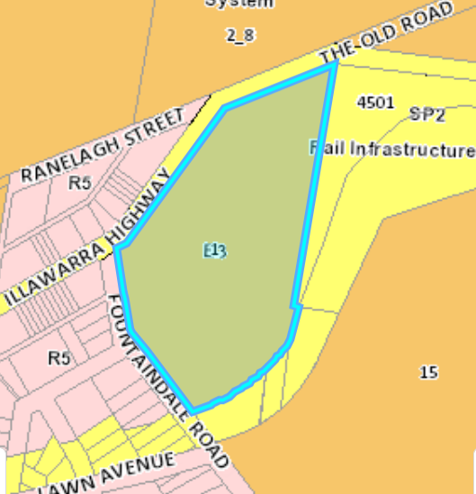
Figure 25: Zoning extract

The objectives of the zone are considered below:

- ‘To protect, manage and restore areas with special ecological, scientific, cultural or aesthetic values.’

This proposal relies upon the redevelopment of the site to enable and ensure the longevity of the areas of protected vegetation to the site. While certain areas will be removed, others will be retained and protected. It is also noted that throughout the assessment a number of eco cabins were removed from a wooded part of the site to improve environmental outcomes.

- To provide for a limited range of development that does not have an adverse effect on those values.

The proposal is supported by a BDAR, revised BDAR, Arborist report, VMP and other supporting documentation which include consideration of ways to reduce the environmental impacts from the development. The proposed eco-cabins have been located throughout the existing hotel grounds and located to areas that are less vegetated with the minimisation of impacts to trees.

- To encourage the retention of the remaining evidence of significant historic and social values expressed in existing landscape and land use patterns.

The proposal specifically retains the heritage building and other aspects i.e. gateway, relocated grotto and significant landscaping and access design (front access via portico – grand entrance). The main hotel has already been maintained and includes numerous original features.

- To minimise the proliferation of buildings and other structures in these sensitive landscape areas.

The eco cabins and eco villas have been located away from the areas of highest value across the site and adjoin an eco-walk through areas of CEEC as shown in Figures 25-26. By way of visual comparison, the extract from the NSW Biodiversity Values Map and areas to be retained as highlighted are shown below:

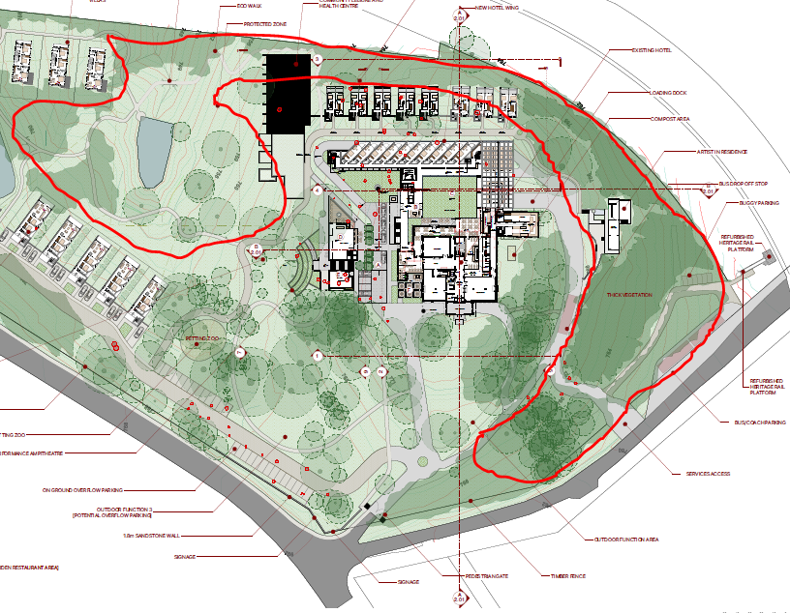
Figures 25 & 26: Comparison of BVM and proposal

- To provide for a restricted range of development and land use activities that provide for rural settlement, sustainable agriculture, other types of economic and employment development, recreation and community amenity in identified drinking water catchment areas.

The existing hotel use and eco cabins will continue and enhance employment opportunities for the area and be ‘restricted’ in terms of types of roles generated by the hotel and ancillary uses.

- To protect significant agricultural resources (soil, water and vegetation) in recognition of their value to Wingecarribee’s longer term economic sustainability.

As previously considered, the proposed addition to the hotel relies on existing use ‘rights’ and associated parts of the Regulation as the site has been occupied by a hotel since 1924. The existing hotel building site is also a locally listed heritage item.

In addition, the cabins and villas proposed to the property are considered to be permissible within the E3 zone, as eco-tourist facilities as considered below: -

‘eco-tourist facility means a building or place that—
(a) provides temporary or short-term accommodation to visitors on a commercial basis, and
(b) is located in or adjacent to an area with special ecological or cultural features, and
(c) is sensitively designed and located so as to minimise bulk, scale and overall physical footprint and any ecological or visual impact.

It may include facilities that are used to provide information or education to visitors and to exhibit or display items.

Note—
See clause 5.13 for requirements in relation to the granting of development consent for eco-tourist facilities.

Eco-tourist facilities are not a type of tourist and visitor accommodation—see the definition of that term in this Dictionary.’

The proposed eco accommodation is additional to the hotel and will be managed by it. Therefore, it will meet (a) above. The eco accommodation will be located adjacent to areas of EEC across this site thereby meeting (b) above. The accommodation has been located away from areas of woodland and within cleared areas (spaces between highly treed sections of the site) and so the number of cabins/villas has been naturally limited thereby meeting (c) above. Also, the cabins are located away from the main hotel accommodation and are linked via a pathway leading to the eco-walk through the EEC area of the site that is being retained and also modified to include a walk with interpretive signage guiding walkers through the area.

In addition to consideration of the matters above, Clause 5.13 as referred to is considered below:

Clause 5.13 states:

‘5.13 Eco-tourist facilities
(1) The objectives of this clause are as follows—

(a) to maintain the environmental and cultural values of land on which development for the purposes of eco-tourist facilities is carried out,’

The proposal retains the land use being a heritage listed hotel and grounds. The ecological values and landscape values re to be protected as outlined in supporting BDAR and other documentation.

‘(b) to provide for sensitively designed and managed eco-tourist facilities that have minimal impact on the environment both on and off-site.’

Conditions have been prepared that require compliance with requirements of supporting documentation which will form part of the consent. The supporting environmental advice has been reviewed by an independent ecologist (twice) and found to be supportive of the eco facility use.

‘(2) This clause applies if development for the purposes of an eco-tourist facility is permitted with development consent under this Plan.

(3) The consent authority must not grant consent under this Plan to carry out development for the purposes of an eco-tourist facility unless the consent authority is satisfied that—

(a) there is a demonstrated connection between the development and the ecological, environmental and cultural values of the site or area, and’

The nexus between the eco accommodation and environmental values is evident as the redevelopment of the wider site will assist with the protection of the most valuable areas of EEC across this site. The BVM shown previously shows that despite the existing hotel use, biodiversity values have remained high across the site due to the retention of much of the natural setting. This setting will be retained and enhanced by the proposal. It will be modified but the use facilitates the management and maintenance of the valuable areas throughout the site.

‘(b) the development will be located, constructed, managed and maintained so as to minimise any impact on, and to conserve, the natural environment, and’

This has been achieved by locating the eco accommodation cleared areas and therefore minimising environmental impacts.

‘(c) the development will enhance an appreciation of the environmental and cultural values of the site or area, and’

The proposal includes an eco-walk with interpretive signage thereby meeting the above requirement.

‘(d) the development will promote positive environmental outcomes and any impact on watercourses, soil quality, heritage and native flora and fauna will be minimal, and’.

Water NSW considered this proposal. Ultimately, Water NSW was satisfied in regard to water quality outcomes across the site. One result is a footbridge to the eco walk across a natural flow path. As stated previously, advice from an ecologist is relied upon along with the supporting reports that evidence that ecological impacts are acceptable subject to conditions as recommended.

‘(e) the site will be maintained (or regenerated where necessary) to ensure the continued protection of natural resources and enhancement of the natural environment, and’

As per documentation submitted, such as a vegetation management plan that forms part of the draft consent.

‘(f) waste generation during construction and operation will be avoided and that any waste will be appropriately removed, and’

This is subject to conditions of consent that aim to minimise any environmental degradation during the construction process.

‘(g) the development will be located to avoid visibility above ridgelines and against escarpments and from watercourses and that any visual intrusion will be minimised through the choice of design, colours, materials and landscaping with local native flora, and’

The proposal meets this requirement as the eco accommodation is located around the edges of a natural valley.

‘(h) any infrastructure services to the site will be provided without significant modification to the environment, and’

This is subject to conditional requirements.

‘(i) any power and water to the site will, where possible, be provided through the use of passive heating and cooling, renewable energy sources and water efficient design, and’

Again, this is subject to conditional requirements and achievable across the site.

‘(j) the development will not adversely affect the agricultural productivity of adjoining land, and’

The site does not directly adjoin such land. However, the works (should they be granted approval) will be the subject of a formal referral under the EPBC Act to the Department of Agriculture, Water and the Environment for formal consideration.

‘(k) the following matters are addressed or provided for in a management strategy for minimising any impact on the natural environment—
(i) measures to remove any threat of serious or irreversible environmental damage,
(ii) the maintenance (or regeneration where necessary) of habitats,
(iii) efficient and minimal energy and water use and waste output,
(iv) mechanisms for monitoring and reviewing the effect of the development on the natural environment,
(v) maintaining improvements on an on-going basis in accordance with relevant ISO 14000 standards relating to management and quality control.’

In consideration of the above (k) (i), the consultant ecologist consideration of the proposal and its management strategy concluded that the proposal was viable subject to conditions.

This matter (i) will ultimately be considered by Federal Government (Department of Agriculture, Water and the Environment) via a formal referral of the works (if granted consent) under the EPBC act as agreed with the proponent and required by the Department. This requirement forms part of one of the conditions as recommended.

In consideration of the above (k) (ii), the site is to be maintained into the future and subject to a vegetation management plan and wider plan of management.

In consideration of the above (k) (iii), Water NSW have considered the water management aspect as well as council’s engineers who are satisfied that the requirements of the relevant SEPP can be met subject to conditions.

In consideration of the above (k) (iv), a vegetation management plan and BDAR subject to conditions will manage this aspect into the future.

In consideration of the above (k) (v), this aspect is a conditional requirement of this consent and has been considered by the proponent.

4.15(1)(a)(ii) - any draft environmental planning instrument that is or has been placed on public exhibition and details of which have been notified to the consent authority (unless the Director-General has notified the consent authority that the making of the draft instrument has been deferred indefinitely or has not been approved), and

There are no draft environmental planning instruments that require consideration.

Principal development standards
The provisions of the WLEP 2010 have been referred to as part of the assessment and the following comments are made in relation to particular principal development standards:

4. | Principal Development Standards | Requirement | Proposed | Complies  Yes/No | Comments
4.2 | Minimum Lot Size | AB3 -40ha | No change – existing – 50,600sqm = 5.06ha | No - existing | No change to existing which is non-compliant.
4.3 | Height of buildings | No control | No change to existing hotel buildings. | N/A | Given the lack of a local planning control – height considered reasonable in the context of existing buildings and lack of direct neighbours to proposed additional accommodation locations.
4.4 | Floor Space Ratio | No control | N/A | Yes | The proposed Floor Space Ratio is consistent with the additional facilities being proposed in the context of no planning control.
4.6 | Exceptions to Development Standards | N/A | N/A | N/A | No proposed variation to Development Standards

4.6 Exceptions to development standards
Council/Consent Authority may consider a written request from the applicant that seeks to justify contravention of a development standard, where that contravention would achieve a better outcome.

The proposal does not include any such exceptions.

Part 5 Miscellaneous Provisions
The provisions of the WLEP 2010 have been referred to as part of the assessment and the following comments are made in relation to particular miscellaneous provisions:

5. | Miscellaneous Provisions | Applies | Complies | Comments
5.10 | Heritage Conservation | Yes | Yes | The heritage values will be preserved through the continued use and retention of the main hotel building and its grounds.  While there are changes proposed to the site, neither Council’s Heritage consultant not its Heritage Committee have raised concerns of issues that would preclude the development as proposed.  The proponent has submitted both aboriginal Heritage advice and a detailed Heritage Impact Assessment submitted in support of the application. Council’s Heritage consultant has not raised specific concerns regarding the quality or accuracy of reports submitted.
5.11 | Bush Fire Hazard Reduction - Bush fire hazard reduction work authorised by the Rural Fires Act 1997 may be carried out on any land without development consent. | Yes | Yes | Bushfire Report submitted with this application and referred to the Rural Fire Service because the proposal was found to comprise Integrated Development. Further to assessment issued a s100B Bushfire Authority with conditions under the Rural Fires Act.
5.13 | Eco-tourist Facilities | Yes | Yes | Considered previously in this report -complies subject to conditions.
5.20 | Standards cannot be used to refuse consent – playing and performing music | Yes | Yes | It is noted that this application must not be refused in relation to licenced premises on the following grounds:  ‘(a) the playing or performance of music, including the following—  (i) the genre of music played or performed, or  (ii) whether the music played or performed is live or amplified, or  (iii) whether the music played or performed is original music, or  (iv) the number of musicians or live entertainment acts playing or performing, or  (v) the type of instruments played,  (b) whether dancing occurs,  (c) the presence or use of a dance floor or another area ordinarily used for dancing,  (d) the direction in which a stage for players or performers faces,  (e) the decorations to be used, including, for example, mirror balls, or lighting used by players or performers.  (2) The consent authority must not refuse consent to development in relation to licensed premises on the grounds of noise caused by the playing or performance of music, if the consent authority is satisfied the noise may be managed and minimised to an acceptable level.’  In this case, suitable conditions have been recommended and a Plan of Management provided to minimise localised impacts.

Part 6 Local Provisions
The provisions of the WLEP 2010 have been referred to as part of the assessment as previously referred to in this assessment report.

Part 7 Additional Local Provisions
The provisions of the WLEP 2010 have been referred to as part of the assessment as previously

7. | Provisions | Applies | Complies | Comments
7.4 | Natural Resources Sensitivity – Biodiversity | Yes | Yes | Considered previously in this report -complies subject to conditions.
7.5 | Natural Resources Sensitivity – Water | Yes | Yes | Considered previously in this report -complies subject to conditions.

4.15(1)(a)(iii) - any development control plan, and

The following checklist should be used to determine which Development Control Plans are relevant:

DCP | Applies Yes/No
Robertson Development Control Plan | Yes

Robertson Village Development Control Plan:

In terms of the local planning controls that more appropriately ‘fit’ the main proposal, the difficulty with this application is that the defined use being ‘tourist and visitor accommodation’ is prohibited within the E3 zone within which the property sits. However, this application relies upon Existing Use Rights under the Act as it has been a hotel for approximately 96 years. Accordingly, prior to the current LEP. As such, a reasonable approach to the assessment of this hotel addition and ancillary uses (part from the eco-cabins / villas which are permissible with consent in the zone) is to consider it against both the Principles of SEPP65 as considered previously and relevant considerations in regard to ‘tourist and visitor accommodation’ under the Robertson Village DCP.

‘Section 10 Tourist and Visitor Accommodation

B10.1 Introduction
Tourist and Visitor Accommodation includes, but is not restricted to, hotel or motel accommodation, serviced apartments, backpacker’s accommodation and bed and breakfast accommodation. Although Bed and Breakfast Accommodation is permissible with consent in the B2, B4 and B5 business zones, the objectives and controls for such development are located in Part C of this Plan as it is the impacts of such development on residential amenity which most concern Council.

All Tourist and Visitor Accommodation is expected to meet the objectives and controls of Part A of this Plan as well as Parts 1 to 5 of Part B. Any additional precinct-specific requirements must also be addressed.

B10.2 Objectives
In assessing a Land Use Application for Tourist and Visitor Accommodation, Council will have due regard to the following objectives:
(a) tourist and visitor accommodation development within Robertson shall be appropriate to the locality and contribute to the supply of a range of accommodation types throughout the Shire;
(b) tourist and visitor accommodation development shall not adversely impact on the amenity of the surrounding area;
(c) tourist and visitor accommodation development shall provide a satisfactory level of health, safety, comfort, amenity and facilities for both workers and visitors.

B10.3 Development Controls
A Land Use Application to be assessed under this Part of the Plan must demonstrate that it meets the objectives stated above. Applicants are also reminded that the development must meet the requirements of Part A and Sections 1 to 5 of Part B of this Plan.’

The following is an assessment of the proposal’s compliance with the numerical standards of the Development Control Plan. Where a variation is proposed to the standards, an assessment is included in the Planning Comments.

DCP Controls | Permitted/  Required | Proposed | Complies  Yes/No
Car Parking | 1 space per hotel room –105 rooms total = 105 car spaces required for hotel use as generated by this requirement.  1 space per 2 employees - 50 employees (potential) – 25 spaces required.  Bar, lounge &dining component – traffic study required.  TOTAL IDENTIFIED REQUIREMENT – 130 spaces | 156 spaces  The cabins/villas have adequate parking as each have parking provided.  As a result, the main parking area will include an excess of 26 spaces in addition to that required.  The excess spaces will be used for functions and other uses on site – the proposal also includes at grade overflow car parking to meet the demand that is flexible.  It is noted that traffic information has been provided in support of this application and referred to the TfNSW for consideration. | Yes

Comment:

Car Parking & Access:
The objectives for Parking and Access are considered met and the numerical standards met subject to the imposition of conditions as recommended.

Sunlight Access and Overshadowing:
The objectives for Sunlight Access and Overshadowing are considered to be met.

Privacy & Security:
The objectives for Privacy and Security are considered to be met.

4.15(1)(a)(iiia)- any planning agreement that has been entered into under section 93F, or any draft planning agreement that a developer has offered to enter into under section 93F, and

No planning agreement has been entered into or is proposed as part of this application.

4.15(1)(a) (iv)- the regulations

The regulations have been considered for this application and relevant conditions imposed.

4.15(1)(a)(v) any coastal zone management plan (within the meaning of the Coastal Protection Act 1979), that apply to the land to which the development application relates

There is no Coastal Zone Management Plan that requires consideration.

4.15(1) (b)- the likely impacts of that development, including environmental impacts on both the natural and built environments, and social and economic impacts in the locality

The proposal is supported subject to the imposition of conditions as recommended. The issues pertaining to the development have been resolved through a process of assessment and negotiation and issues identified in the Executive summary of this report and throughout the assessment under local controls.

Section 94 (7.11) Contributions Plan
This has been considered and contributions applied to the proposal and included in the draft consent.

4.15(1) (c)- the suitability of the site for the development,

The site is within the E3 zone and is currently developed with a Hotel, accordingly, the site is considered suitable for the development.

4.15(1) (e) the public interest.

The proposal is considered to be in the public interest, subject to the inclusion of recommended conditions.

Conclusion and Recommendation

All relevant planning matters have been addressed, and/or conditions imposed to ensure that any potential impacts are negated. It is considered that this report adequately addresses the impacts of the development in terms of health, visual amenity, suitability of the site, services and utilities, flora and fauna, traffic, and the many other areas identified above.

The application has been assessed having regard to Section 4.15 of the Environmental Planning and Assessment Act 1979, the Wingecarribee Local Environmental Plan 2010 and the Rural Lands and Robertson Village Development Control Plans and considered to be acceptable development and is recommended for Conditional Approval.

Prepared by:

Nancy Sample
Manager Development Assessment

ADDENDUM – Response to the formal Record of Deferral dated 20 April 2021 further to the public meeting held on 14 April 2021

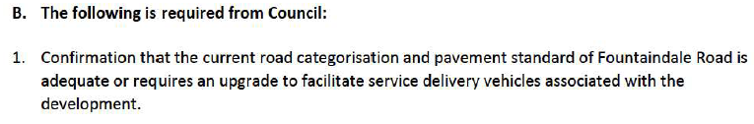
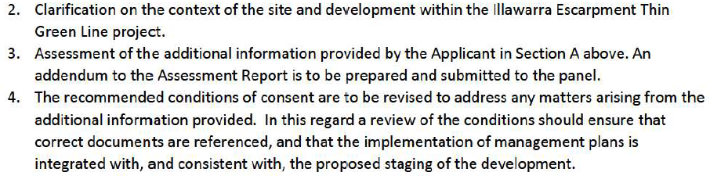

In Response to requests in B above:

- Fountaindale Road is a Local Access Road and is sealed. The road is considered to be in good condition and has no load limits. Accordingly, no upgrade has been triggered by the proposal.

Extract from Council’s GIS system is included below and has been discussed with Council’s Senior Development Engineer -Tula Bhattarai.

- The Thin Green Line project is run at local level by David Rush (Bush Connect Project Manager, Land for Wildlife Assessor, Illawarra Shoalhaven GER Region) who I have been in contact with and who outlined what it was and was not. It is a project helping landholders to ‘manage and link critical habitat for wildlife’. It is not a wildlife corridor that forms part of any wider adopted formal strategy i.e. strategy or planning document that triggers formal consideration of it as an entity. It is, however, noted and supported by our Environment Team at WSC.

The information sheet for this project provided by David Rush is attached as Appendix 1. In terms of its relevance to this DA, two of the vegetation communities that are the focus of this project are found in the grounds of the Robertson Hotel being Robertson Basalt Tall Open Forest and Woodland and Robertson Rainforest (Critically Endangered vegetation communities under the Environment Protection and Biodiversity Conservation Act 1999).

- Addendum to assessment report considering the submitted information is attached as Appendix 2.

Appendix 1: The Thin Green Line

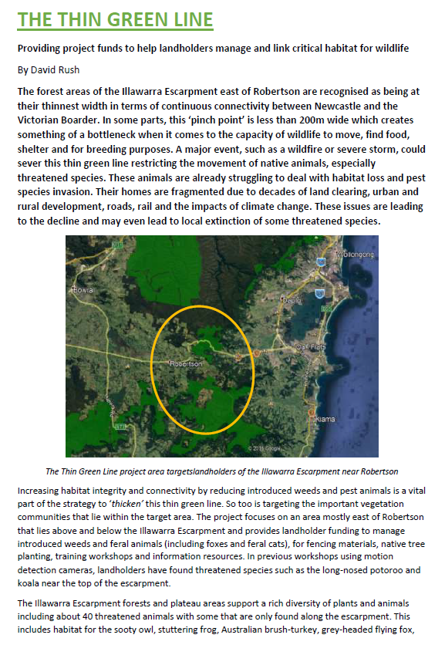

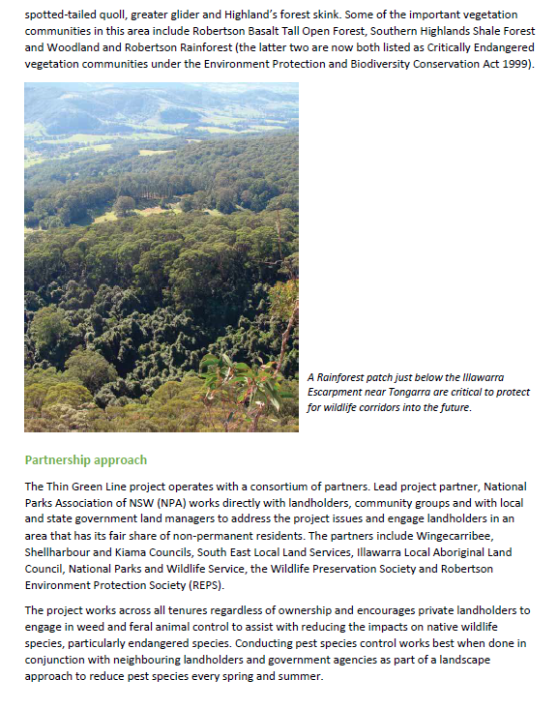

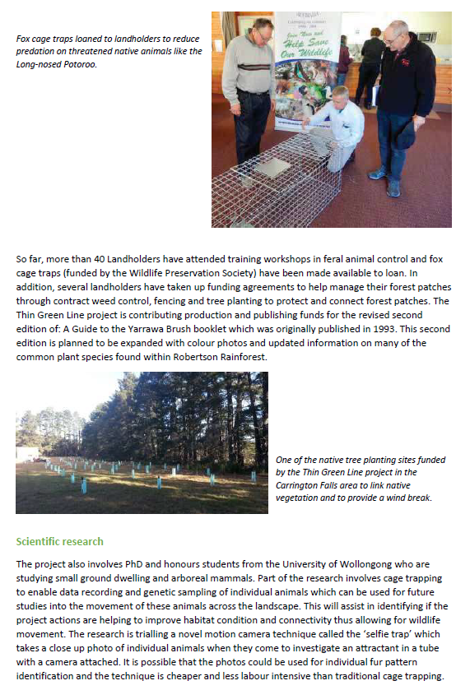

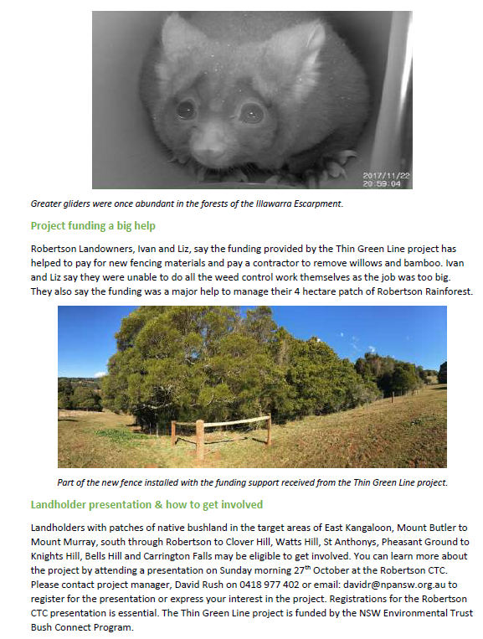

Appendix 2: Assessment of Information Submitted By Proponent In Response To SRPP Deferral Dated 20 April 2021

Please find consideration of information submitted in response to the following:

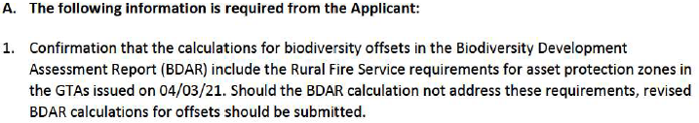

By way of response, the applicant has submitted the following: Letter from Narla Environment pty dated 27.04.2021 Letter and Tree removal Plan from Chris and Charlotte Webb dated 20.04.2021 Letter from Peterson Bushfire dates 07.05.2021.

The letter from Narla confirms that:

‘Narla can confirm that the calculations for biodiversity offsets in the BDAR include the Rural Fire Service (RFS) requirements for asset protection zones. Specifically, all areas to be maintained as an Inner Protection Area (IPA) for bushfire protection have been assigned a future canopy cover of 14.9%, which meets the RFS requirement of less than 15%. All other vegetative growth forms (shrubs, grasses, forbs, ferns, other, coarse woody debris, leaf litter) within the IPA have been assigned a future cover of 0% for the purposes of biodiversity offset calculation- also meeting the minimum requirements of the RFS.’

The letter from Charlotte Webb confirms that:

‘Re: ‘Robertson Hotel’ Landscape Compliance with RFS 15% Canopy Cover PPSSTH-43 – WINGECARRIBEE – 20/1069

The landscape plans have been revised to reduce the tree canopy cover of the site, excluding the area of protected and endangered Robertson Basalt Tall Open Forest and Robertson Rainforest.

The target of 15% canopy cover equates to approximately 5,909m2. With the removal of 5 pine trees, a cypress and two smaller trees a canopy cover of 6,592m2 can be achieved with minimal impact on the overall heritage significance of the setting of the hotel, the heritage value of the garden or the removal of any heritage significant individual tree. This area equates to approximately 16.7% canopy cover of the site.

Refer to Landscape Plan LS-03, Rev C, prepared by Chris & Charlotte Webb Pty Ltd.’

Council’s consultant ecologist considered the information from Narla and commented:

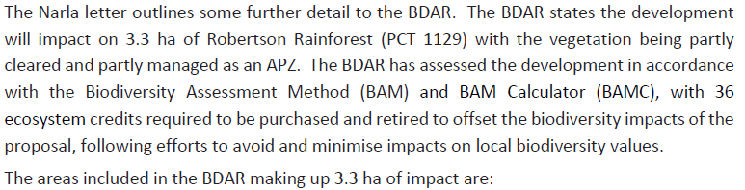
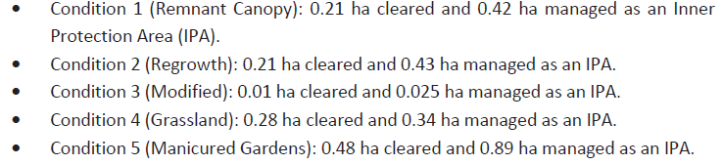
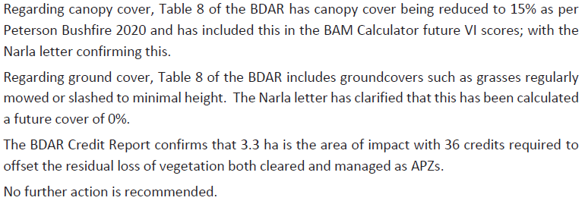
The advice from Eco Logical Australia (Diane Campbell- Principal Ecologist) dated 02 June concludes:

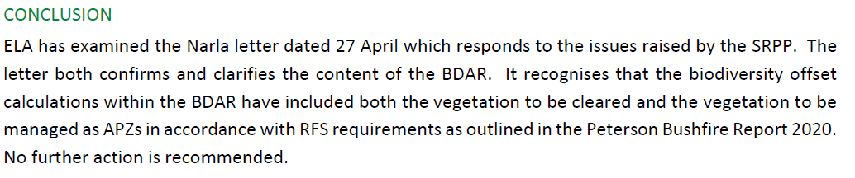
These conclusions are not contested by Council and the application is supported.

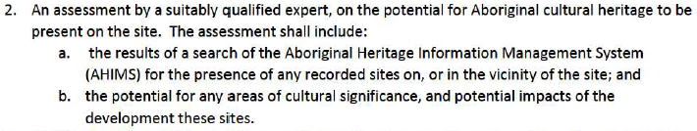

The applicant has submitted the Coast History and Heritage letter dated 11.05.2021 which confirms that:

• ‘No Aboriginal cultural heritage has been documented on the AHIMS Register within a kilometre of the property.’

The report was forwarded to our heritage consultant who noted its content but who had previously commented that the site did not have any potential for aboriginal heritage due to its use and the consideration of the AHIMS which states that there is nothing identified to this site.

The report finds that:

‘Based on these observations we have made the following conclusions:
• No areas of Aboriginal archaeological potential have been identified within the areas of Stages 1, 4
or 8. Accordingly, no further Aboriginal heritage investigations are required in the areas of Stages
1, 4 or 8 prior to the commencement of site works. This will be documented in a completed Due
Diligence Aboriginal Heritage Assessment report, to be forwarded to Council.

• Some areas within Stages 2, 3, 5, 6 and 7 will require Aboriginal archaeological test excavation to
determine if any Aboriginal archaeological remains are present. The extent of these areas is
currently being determined. As it is highly unlikely that any such remains will be intact and
extensive, these excavations could be undertaken at a later stage as a condition of development
consent, prior to the commencement of bulk earthworks in these areas.

• The recommended archaeological test excavations should be undertaken in accordance with the
Heritage NSW Code of Practice for Archaeological Investigation of Aboriginal Objects in New South
Wales (the “Code of Practice’).3 This requires the Aboriginal community consultation in
accordance with Section 60(1) – 60(7) of the National Parks & Wildlife Regulation 2019 (‘the
Regulation’). The results of the archaeological test excavations would be documented in an
Aboriginal Cultural Heritage Assessment Report, prepared in accordance with the Code of Practice.
In the event that Aboriginal archaeological remains are found which cannot be protected within the scope of proposed impacts in these areas, they will require archaeological salvage or collection under a s90 Aboriginal Heritage Impact Permit under the National Parks & Wildlife Act 1974.’

The report states that:

‘Coast will soon complete the Due Diligence Aboriginal Heritage Assessment which will contain final recommendations concluding that no further Aboriginal heritage investigations are required in relation to Stages 1, 4 and 8.

Coast has also been engaged by the proponents to prepare an Aboriginal Cultural Heritage Assessment Report, determine the precise areas requiring archaeological test excavation within the areas of Stages 2, 3, 5, 6 and 7, undertake the required Aboriginal community consultation in accordance with the Regulation, and carry out the archaeological test excavations as required.’

The report concludes that:

‘Based on the findings outlined above, it is considered appropriate that the recommended test
excavations and any further salvage or collection works under an Aboriginal Heritage Impact Permit (if required) are undertaken after development consent has been issued and prior to any bulk
earthworks in Stages 2, 3, 5, 6 and 7.’

Accordingly, the report will be included in the consent and its recommendations form part of the conditions as recommended.

The proponents traffic consultant Hemanote Consultants provided an addendum traffic statement dated 11 May 2021 responding to the request which concluded that:

‘…Therefore, the overall estimated peak hour traffic generation for the subject development would be in the range between 96 to 106 vehicle trips (i.e. 75 + 21 = 96 or 75 + 31 = 106). However, the overall estimated peak hour net increase in traffic generation as a result of the proposed redevelopment of the site would be in the range between 72 to 82 vehicle trips (i.e. 51 + 21 = 72 or 51 + 31 = 82).’

Council’s Traffic Engineer Frank Iacono reviewed the letter and its assumptions and responded as follows:

‘I have reviewed the “Traffic Reply letter to RFI – The Robertson Hotel – May 2021.pdf”.

The traffic generation of 3 trips per room and an evening trip rate of 0.4 per room is consistent with RTA Guide to Traffic Generating Developments 2002

The overall traffic generation agrees with the RTA Guide i.e. 75 peak hour trips per hour.

They have also made an assumption that there would be up to 62 persons visiting the site (in addition to accommodation) which appears reasonable and the resultant trip generation rate of 106 vehicle trips in the peak hour also appears a reasonable estimation.

Allowing for existing usage they are stating that the development would add between 72 and 82 vehicle trips per hour.

The relevant number, in my opinion, is 106 vehicle trips per hour that needs to be addressed (i.e. regardless of what the site may currently be generating).

It would have been useful if they had provided surveys of actual usage rather than basing it on assumptions but, it would appear that the treatment that I previously saw that TfNSW (RMS) had been considering would not alter.

The assumptions in the “Traffic Reply letter to RFI – The Robertson Hotel – May 2021.pdf” appear to be reasonable but, as stated, a survey of existing activity over a full occupancy weekend would better support the assumptions stated. It could also be argued that a survey of the existing development could also understate the generation once the development is improved as the existing development may not be attracting to full potential.

Overall I feel comfortable with the rates and traffic generation provided in the “Traffic Reply letter to RFI – The Robertson Hotel – May 2021.pdf”.’

Accordingly, Council supports the application as per the original assessment subject to the imposition of conditions of consent as recommended.

The proponents state that:

‘AEA Grand Hotel, who are the owners and operators of the property have updated Plan of Management to include:
- information relating to limiting and managing noise generation
- plan of hotel venues
- plan showing location of dedicated staff accommodation on site Please note that the Plan of Management reflects the Acoustic Report provided by Rodney Stevens Acoustics and subsequent Council Conditions.’

Our Environmental Health officer has considered the additional information and responded as follows and does not object to the proposal or reports supplied as follows:

‘It appears that the report Noise Impact Assessment Proposed Additions - The Robertson Hotel 1 Fountaindale Rd, Robertson NSW 2577 by Rodney Stevens Acoustics Pty Ltd (Ref. 200332R1, Rev. 2, dated 12/3/2021) (ECM Document Set ID: 36921) (‘Acoustic Report’) has been prepared by a suitably qualified acoustic professional. The Report has addressed the likely noise-generating scenarios and provided a number of recommendations. The report shows compliance with the applicable noise criteria with the implementation of the recommendations outlined in the Report.
Accordingly, I suggest that the following Noise conditions of consent should imposed:
- G044 – modified as follows:
Noise Control Measures
With reference to the Report titled ‘Noise Impact Assessment Proposed Additions - The Robertson Hotel 1 Fountaindale Rd, Robertson NSW 2577’ by Rodney Stevens Acoustics Pty Ltd (Ref. 200332R1, Rev. 2, dated 12/3/2021) the Applicant and/or operator shall implement the noise control measures outlined in Part 6 (pp.18-19) of the Report.
Reason: To ensure that noise emissions from the development satisfy legislative requirements and prevent loss of amenity to the area.
- G047 – modified as follows:
Operational Noise Levels
The Applicant shall ensure operational noise levels (L_{Aeq}) for the development does not exceed rating background level by more than 5 dB(A) when measured at the boundary of the nearest affected residence. Without limiting the above, operational noise levels must also fall within the requirements of the acceptable noise level amenity of the area as specified by the NSW EPA Noise Policy for Industry. In the event that operational noise is identified as exceeding the requirements of this condition, the Applicant will be required to undertake such works as is necessary to remedy such exceedance within a period determined by Council.
Reason: To ensure that noise emissions from the development satisfy legislative requirements and prevent loss of amenity to the area.
- G048 – modified as follows:
Noise Control
Noise from patrons and amplified sound emitted from the premises shall also comply with the following criteria:
- The LA10 noise level emitted from the use must not exceed the background noise level in any Octave Band Centre Frequency (31.5 Hz to 8 kHz inclusive) by more than 5 dB between the hours of 7.00am and 12.00 midnight when assessed at the boundary of any affected residence.
- The LA10 noise level emitted from the use must not exceed the background noise level in any Octave Band Centre Frequency (31.5 Hz to 8 kHz inclusive) between the hours of 12.00 midnight and 7.00am when assessed at the boundary of any affected residence.
- Notwithstanding compliance with (a) and (b) above, the noise from the use must not be audible within any habitable room in any residential property between the hours of 12.00 midnight and 7.00am.
In the event that operational noise is identified as exceeding the requirements of this condition, the Applicant will be required to undertake such works as is necessary to remedy such exceedance within a period determined by Council.
Reason: To prevent loss of amenity to the area.
- G051 – modified as follows:
Noise from Mechanical Equipment
The proposed use of the premises and the operation of all plant and equipment shall not give rise to an 'offensive noise' as defined in the Protection of the Environment Operations Act 1997.
Prior to the application for a Construction Certificate, the developer must submit to the Council or the accredited certifier a report from a suitably qualified acoustic consultant (who is a member of either the Australian Acoustical Society or the Association of Australian Acoustical Consultants). The report must be submitted with or before the application for a Construction Certificate and must:
- include the measurements and calculations; and
- certify that the method of treating all mechanical equipment will ensure that the noise level, as measured at the most or potentially most affected noise sensitive locations, will not exceed the recommended acceptable project specific noise levels, detailed in the NSW EPA Noise Policy for Industry.

If the mechanical equipment is to be operated between 10pm-7am on weekdays and/or 10pm-8am on weekends and public holidays the report must also certify that when operated it will be inaudible from within a habitable room of another residential premises (regardless of whether any door or window is open).
After completion of the works, prior to the issue of the Occupation Certificate, the developer must submit to the Council or the accredited certifier, a report from a suitably qualified acoustic consultant (as above) verifying that the works as installed meet the above design conditions.
Reason: To ensure that noise emissions from the development satisfy legislative requirements and prevent loss of amenity to the area.
I suggest that the following Food safety & hygiene conditions should be imposed:
- G063 - modified as follows:
Food Premises - General
The construction and operation of the food premises shall comply with all applicable legislation and standards, including:
- Food Act 2003;
- Food Regulation 2010;
- Food Standards Code, Food Standard 3.2.3;
- Australian Standard AS4674–2004 Design, Construction and Fit out of Food Premises; and
- Australian Standard AS1668.2–2012 The use of ventilation and air-conditioning in buildings: Mechanical ventilation in buildings.
In the event that the design, construction and/or fit-out of food handling areas is inadequate for the food handling activities carried out on the premises, the Applicant will be required to undertake such works as is necessary to remedy any non-compliance with the above-mentioned legislation and Standards within a period determined by Council.
Reason: Compliance with legislation and standards.
- Food premises compliance to be assessed prior to the issue of the Construction Certificate
Prior to the issue of the Construction Certificate, detailed drawing of the design, construction and fit-out of the food shall be submitted to either Council or the nominated Accredited Certifier to be assessed for compliance with the following standards:
- Food Standards Code, Food Standard 3.2.3;
- Australian Standard AS4674–2004 Design, Construction and Fit out of Food Premises; and
- Australian Standard AS1668.2–2012 The use of ventilation and air-conditioning in buildings: Mechanical ventilation in buildings.
Reason: To ensure compliance with legislation and standards.
- E101 - modified as follows:
Food Shop Requirements
Prior to the issue of the Occupation Certificate, the food premises shall be set up in accordance with:
- Food Standards Code, Food Standard 3.2.3;
- Australian Standard AS4674–2004 Design, Construction and Fit out of Food Premises; and
- Australian Standard AS1668.2–2012 The use of ventilation and air-conditioning in buildings: Mechanical ventilation in buildings.
Reason: To ensure compliance with legislation and standards.
- E103 - modified as follows:
Food Shop Notification Requirement
Occupation of the premises shall not occur until a notification form has been submitted to Council for the food business conducted on the premises.
Evidence of compliance of the above shall be submitted to Council prior to the issue of the Occupation Certificate and commencement of business.
Reason: Registration and notification to relevant authorities.
Accordingly, Council supports the application as per the original assessment subject to the imposition of conditions of consent as recommended.

The proponent has provided written and plan form information as follows:

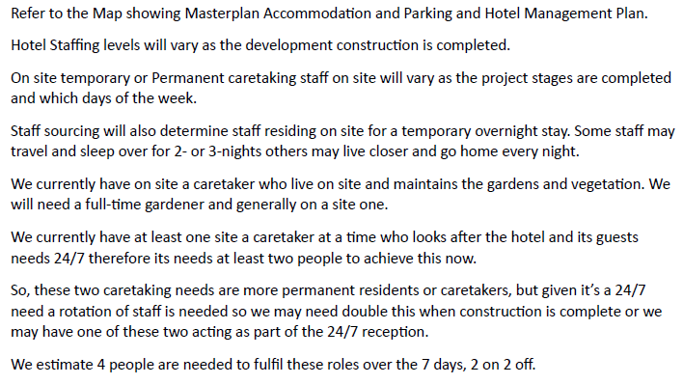

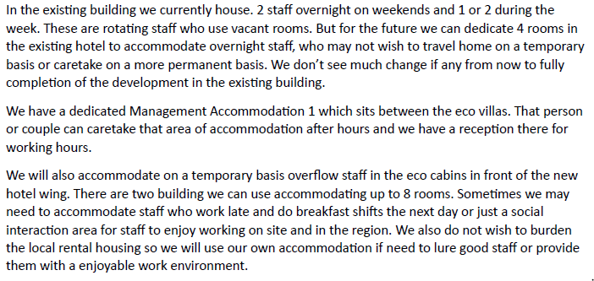
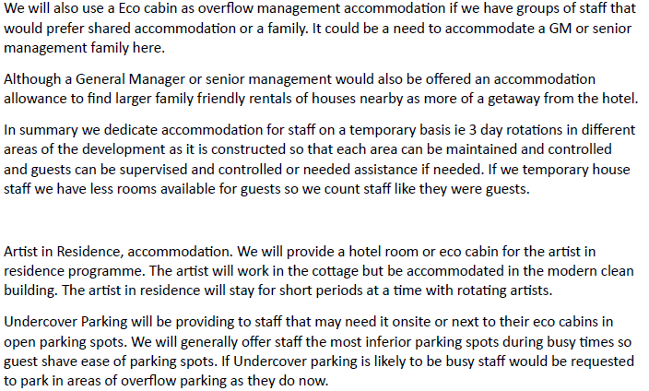

Accordingly, Council supports the application as per the original assessment subject to the imposition of conditions of consent as recommended.

A revised detailed construction staging plan prepared by Cohort Engineering – Dwg No. 1931C01- has been provided and a schedule associated with it to clarify the tasks within each stage. This forms part of the consent as drafted for consideration and is acceptable to Council. The proponent will be charged developer contributions by stage to be calculated at the time of payment due to the CPI changes that will occur over time.

Accordingly, Council supports the application as per the original assessment subject to the imposition of conditions of consent as recommended.

